Ali El Zein & Ismail Sanan
Types of problems :

Decision problems : problems with YES or No answer.

Decidable : exists an algorithm to solve them.

Tractable➔solvable in reasonable time.

Intractable➔non solvable in a reasonable time.

Undecidable : no Algorithm to solve them.

Search problems : does a valid solution exists and which one it is

Verification problems : given a solution make sure that it is really one.

Optimization problems : if a solution exists , which is the best one.

Type of classes :

The P class:

It is a Decidable and tractable decision problems and a polynomial algorithm that solve them.

An algorithm is polynomial iff working on n data , given a cosntant c>0 ,

The algorithm will terminates in a finite number of steps upperboundednc.

The NP class :

It is a Decidable and tractable decision problems and an exponential algorithm

that solve them but we are not sure about the existance of a polynomial algorithm to solve thems problems while we have a polynomial verification algorithms to check whether the solution is really a solution.

REMARK : NP stands for NON-DETERMINISTIC POLYNOMIAL and refers to NON-DETERMINISTIC TURING MACHINE.

Question : P is a subset or coincide with NP ?
Answer : We don’t know this but probably P is a proper subset of NP.

The NP-Complete class:

Itis NP.

NP + Polynomial Transformation ➔ NP-Complete.

So if we find a polynomial algorithm for all the problems in this class then we can find an algorithm for all NP problems through transformation (HIGHLY IMPROBABLE).

Then the existence of NP-Complete ➔ P is a proper subset of NP.

The NP-H class :

If every problem in NP may be reduced to it in a polynomial time(even if It

doesn’t belong to NP).

Any other problem in NP may be reduced to it by means of polynomial transformation.

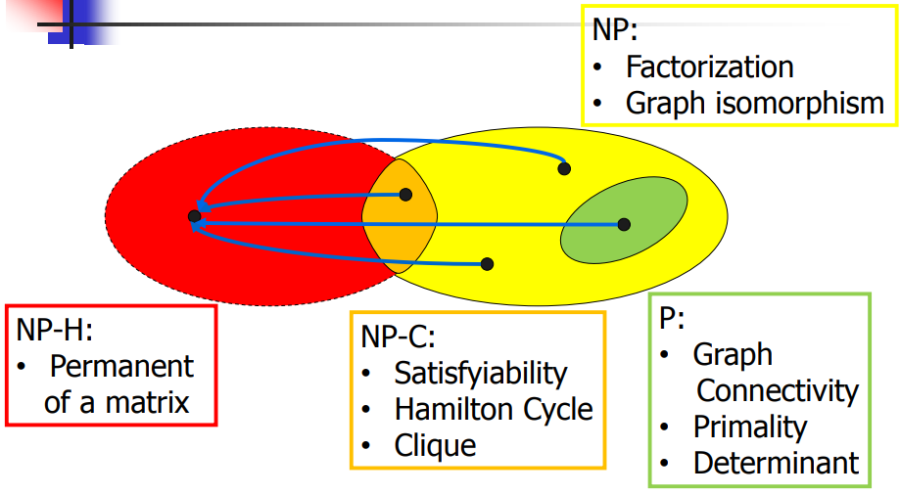

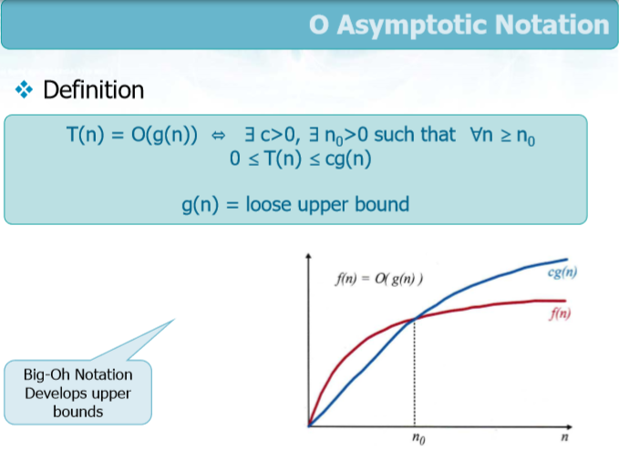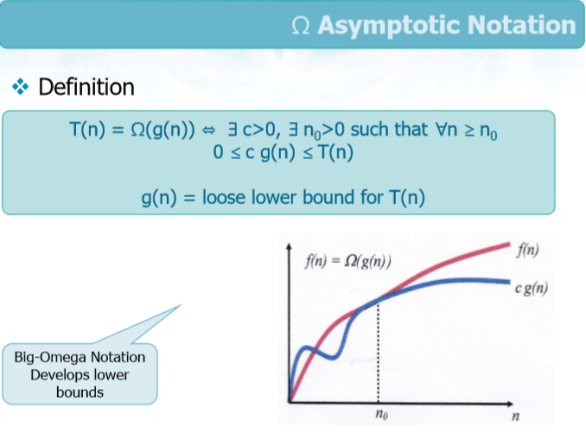

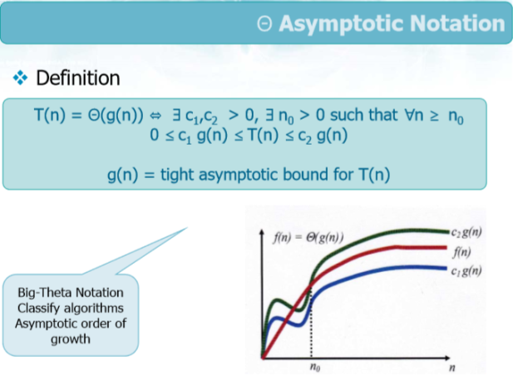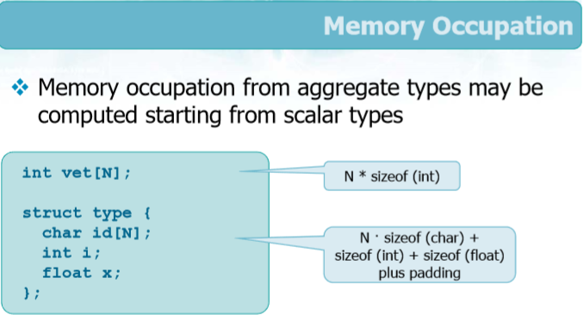

Quick Find :

Read pair (p,q).

Find :

check if (id[p]=id[q]).

Do nothing and move to the next.

replace all id[p] values with id[q] values.

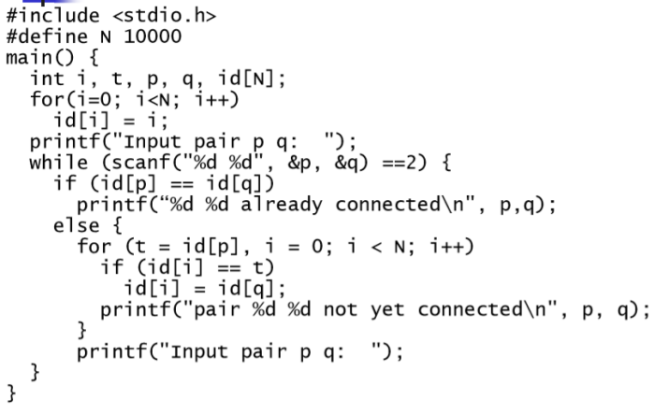

Quick Union :

Algorithm:

Repeatforallthepairs(p,q)

Readpair(p,q)

If(id[p])*=(id[q])*

Do nothing(the pair is already connected )
and move on to the next pair
Else

id[(id[p])*]=(id[q])* (connect the pair).

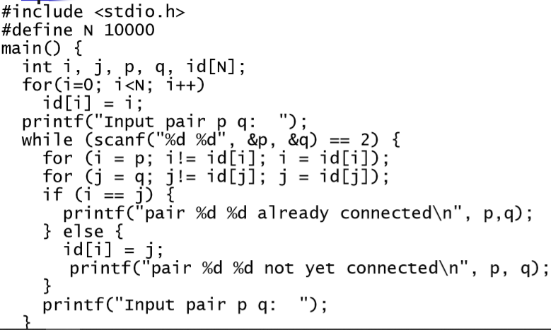

Weighted Quick Union :

To shorten the chain length,keep track of the number of elements in each tree (array) and connect the smaller tree to the larger one.

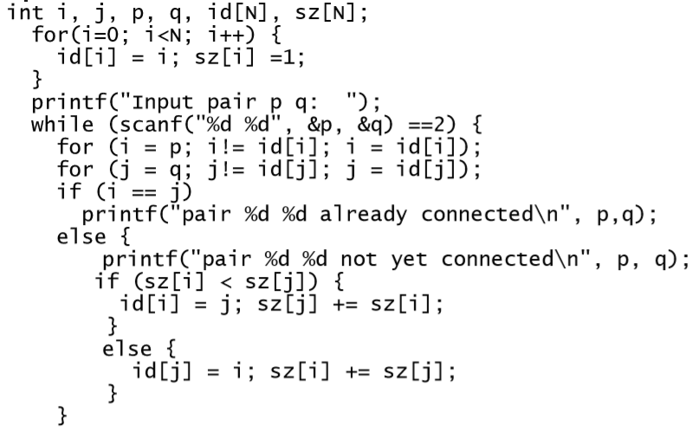

SearchAlgorithms :

Linear/Sequential Search ➔ scan the array from the first element to potentially the last element comparing key k with the value.

T(n) = O(n)

CODING :

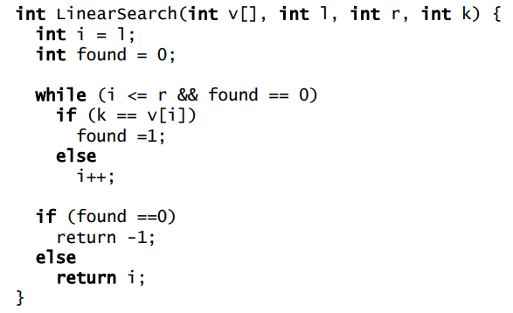

Binary Search ➔ scanning a sorted array for the presence of the key k.

At each step we compare k with the middle element of the array : = : termination success.

> : search continues on the right subarray.

< : search continues on the left subarray.

T(n) = O(logn)

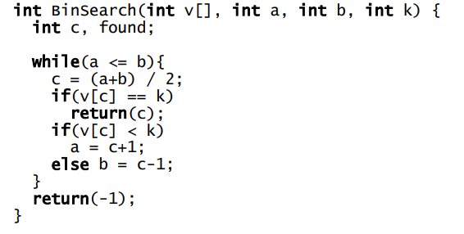

REMARK:
STABLE
A sorting algorithm is said to be stable if two objects with equal keys appear in the same order in sorted output as they appear in the input array to be sorted.
IN-PLACE
Means that the input and output occupy the same memory storage space.
The list that it receives as input instead of creating a new list that is then modified.

SortingAlgorithm :

Insertion sort ➔ array partitioned into 2 sub-arrays

Left array : sorted.

Right array : unsorted.

At each step we expand the sorted sub-array by insertion one more element.

Termination is done when all the element are propery in order.

This sort is : in place , stable.

Where the number of exchanges in worst case : O(n2)

Where the number of comparisonsin worst case : O(n2)

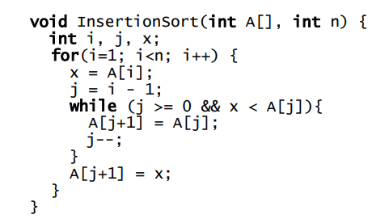

Bubble Sort ➔ array partitioned into 2 sub-arrays

Left array : unsorted ,initially it coincides with A.

Right array : sorted , initially empty.

Compare successive elements A[i] ? A[i+1] and swap.

This sort is : in place , stable , T(n)=O(n2)

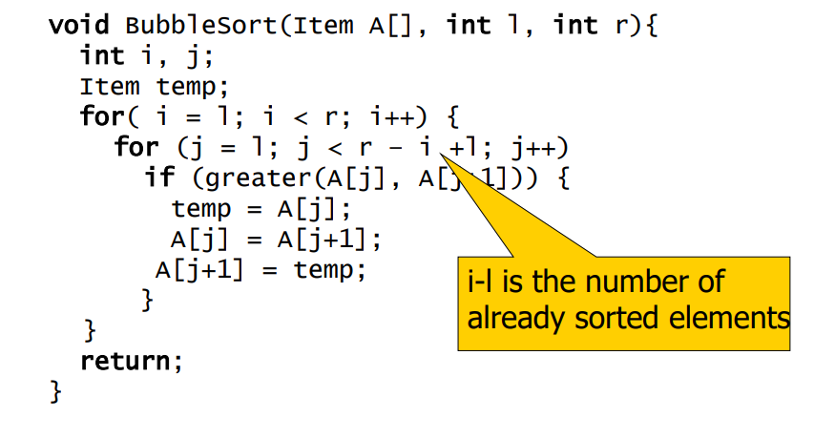

Selection Sort ➔ array partitioned into 2 sub-arrays

Right array : unsorted ,initially it coincides with A.

Left array : sorted , initially empty.

Search for the minimum in the right sub-array.

This sort is : in place , not stable .

Where the number of exchanges in worst case : O(n)

Where the number of comparisons in worst case : O(n2)

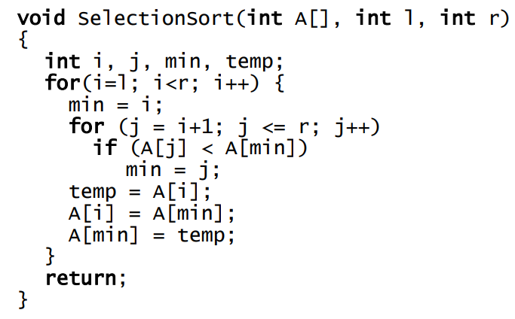

Shell Sort ➔ compare elements at distance h and defining a decreasing sequence of integers ending with 1.

Then an array is formed by non-contiguous sequences composed by elements whose distance is h is a h-sorted array.

Then for each subsequences we apply insertion sort.
this sort is : not stable , in place

While this sort with :

Shell’s original sequence 1-2-4-8-16…: O(n2)

Knuth’ssequence1-4-13-40-121…: O(n3/2)

Sequence 1-8-23-77-281…: O(n4/3)

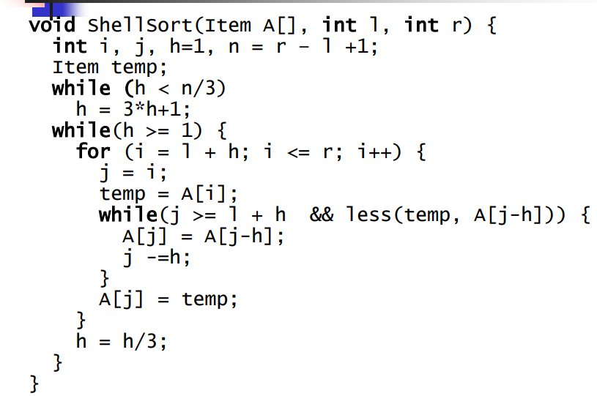

Counting Sort ➔ 3 array are defined .

Starting array : A[0…n-1].

Resulting array : B[0…n-1].

Occurrence array : C[k] if data belong to the range [0…k-1].

This sort is : stable ,not in place.

Initialization loop for C : O(k).

Loop to compute simple occurrence : O(n).

Loop to compute multiple occurrence : O(k).

Loop to copy result in B : O(n).

Loop to copy in A: O(n).
Then for all Counting sort : T(n) = O(n).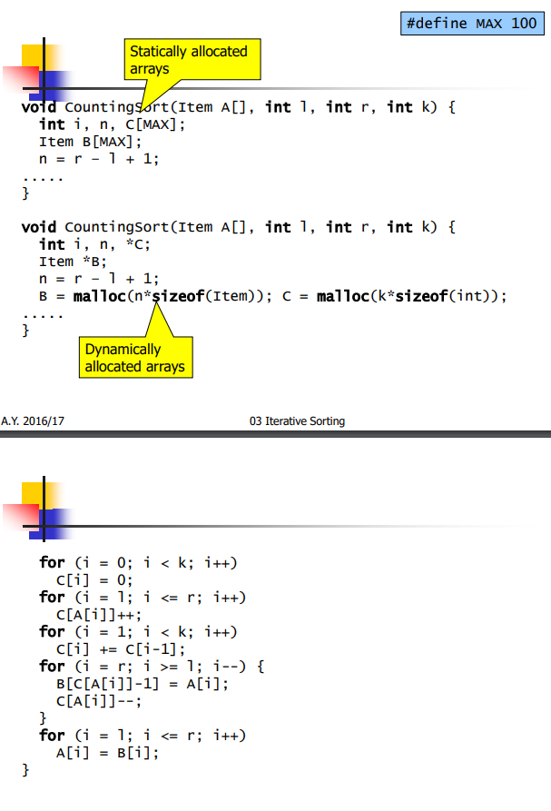

Merge Sort ➔ DIVISION→RECURSION→RECOMBINATION

1)Division : 2 sub-arrays left and right with respect to the middle element.

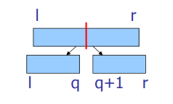

2)Recursion : Merge sort on array L.

Merge sort on array R.

Termination condition with 1(l=r) or 0(l>r)

3)Recombination :merging 2 sorted subarrays into one sorted one.

This sort is : not in place (uses auxiliary arrays), stable.

Complexity :

Divide : divide array : D(n) : O(1).

Solve : solve 2 sub-problems of size n/2 ➔ 2T(n/2).

Termination : simple test O(1).

Combine : based on merge C(n) = O(n).

Then :

C(n)+D(n) = O(n) ➔T(n)=2T(n/2)+n if n>1

T(1)=1 if n=1

➔T(n)=O(nlogn).

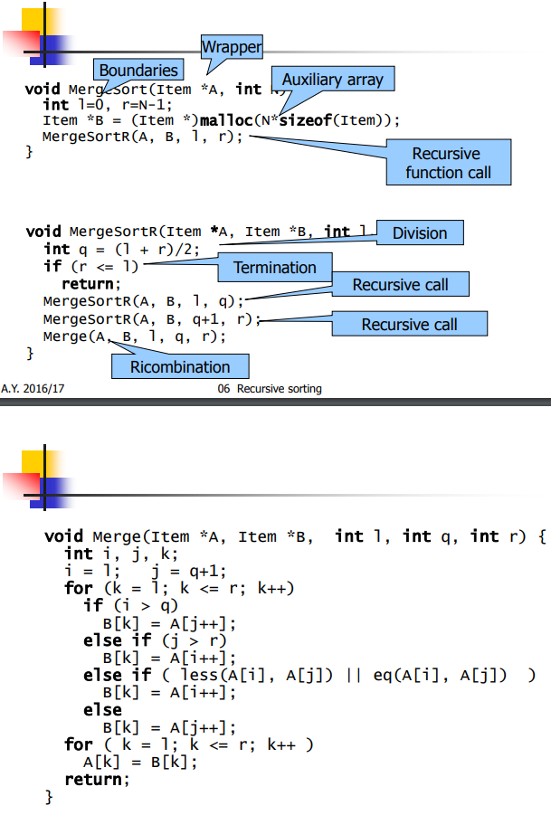

Quick Sort ➔ this sort is not stable,in place.

1)Division : partitioning the array a[l…r] into to arrays L & R

Given a pivot element x.

L ➔ a[l…q-1] contains all elements < x .

R ➔ a[q+1…r] contains all elements > x .

X is in the right place.

Division doesn’t necesserly halve the array.

2)Recursion : QuickSort on subarray L a[l…q-1]

QuickSort on subarray R a[q+1…r]

Terimination code when the array has 1 element

3)None.

Complexity : T(n) = T(n-1) + n n>=2

T(1) = 1 n=1

Then worst case : T(n) = O(n2)

Then best case : T(n) = O(nlogn)

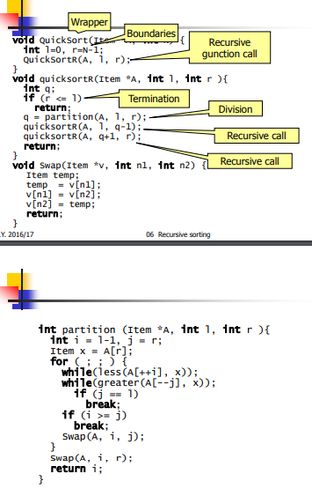

Heap Sort ➔ Max heap or Min heap.
Structural property :
almost complete all levels are complete except the last one.

Functional property :
node !=root ➔ key(parent(node))>= or <= key(node)

Consequence : max key or min key is the root.

We can use the “struct” method to create the heap node.

There is three operations also for this sort .

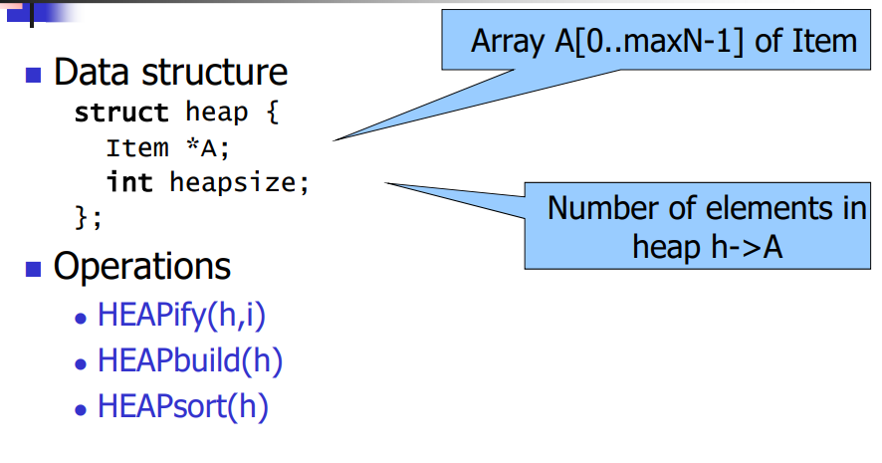

The root is stored in h->A[0].

Left child is h->A[LEFT(i)] where LEFT(i)=2*i+1.

Right child is h->A[RIGHT(i)] where RIGHT(i)=2*i+2.

Parent is h->A[PARENT(i)] where PARENT(i)=(i-1)/2.

1)HEAPIFY :T(n) = O(logn)

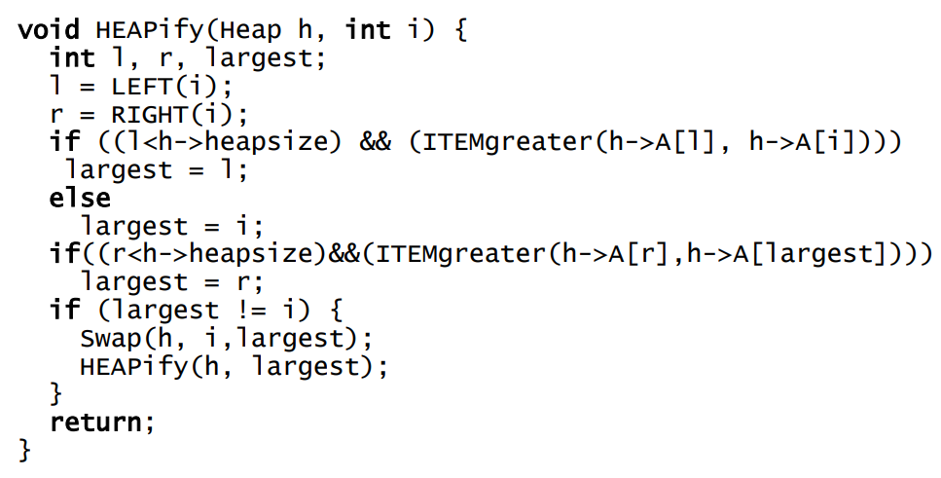

2)HEAPBUILD :
turns binary tree stored in the array A into a heap.
leaves are heaps.
apply heapify starting from the parent node of the last pair of leaves back until the root.
T(n) = O(n)
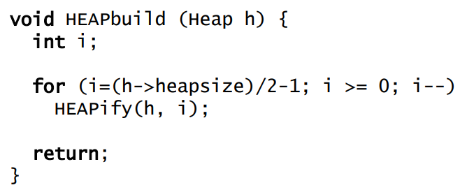

3)HEAPSORT :
Turns the array into a heap using HEAPBUILD.
swaps first and the last element.
decrease heap size by 1.

Reinforces the heap property heap.

Repeat until heap is empty.

T(n) = O(nlogn) , in place , not stable
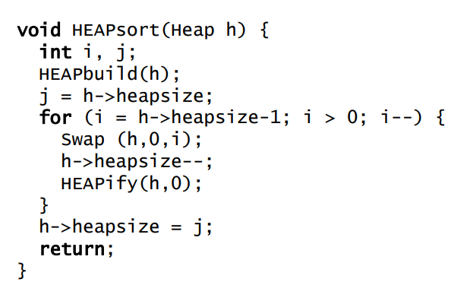

Priority Code : the priority queue is data structure PQ to store elements of type ITEM , each of them including a priority field.

MAIN OPERATION :insert , extract max , read max ,change priority.

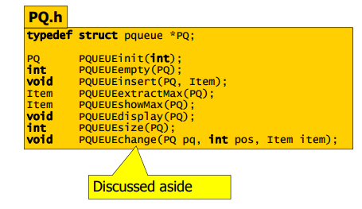

The priority queue stores data :Array(heap) pq->A of ITEM data.

HeapSize integer.

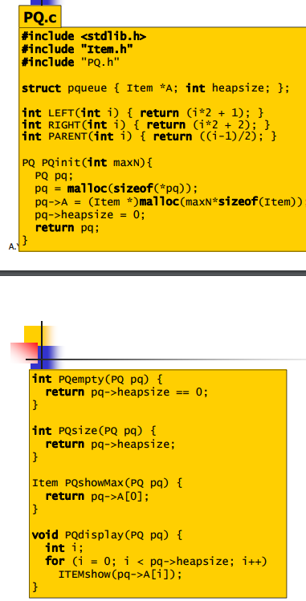

1) PQINSERT : Add leaf to the tree.

Form current node up compare the parent’s key with the new nodes key ,moving the parent’s data from the parent to the child when the inserted key is greater otherwise insert the data in the current node.

T(n) = O(logn)

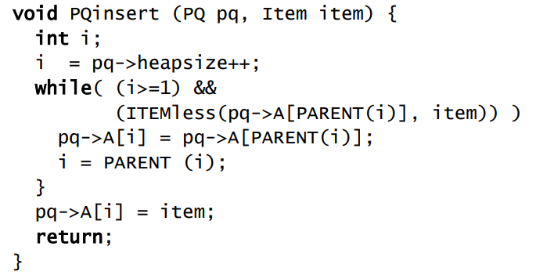

2)PQExctractMax : modify the head ,by extracting the largest value stored in the root.

Swap root and the last leaf.

Reduce by one the root size.

Restore the heap property by applying the HEAPIFY.

T(n)=O(logn).

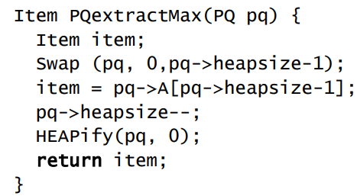

3)PQCHANGE : modify the property of an element in a given position .

Moving up from the given position to the root at most by comparing the parent’s key with the modified key.

Moving down from the parent to the child the largest key ,otherwise insert the key into the current node.

Apply HEAPIFY started from the given position.

T(n) =O(logn).

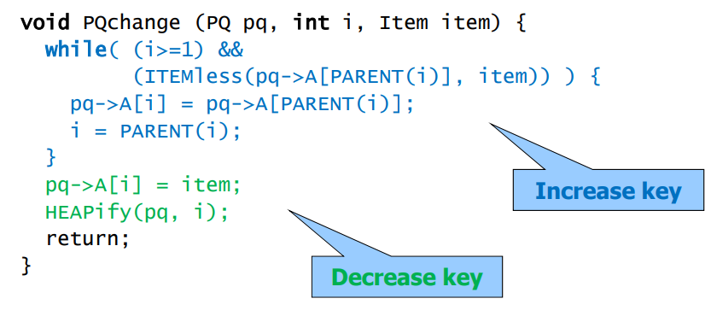
In tail recursive functions :
1) Calculations are performed first.
2) Recursive calls are done after.
3) Current results are passed to future calls.

4) Current stack frame is not needed anymore.

Graphs :

For the graphs V (vertices) and E(edges).

Types of graphs :

1)Directed : sorted pair of vertices.

2)Undirected : unsorted pair of vertices.

If the Directed graph is self-loop-free ➔ SIMPLE GRAPH.

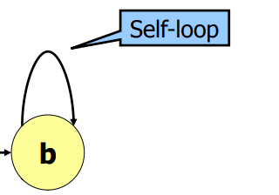

Self-loop occurs only in directed graph.

Degree of a vertex :

Undirected graph ➔ the degree is the number of incident edges.

Directed graph ➔ the degree is the summation of the incoming edges and the outgoing edges.

Path is the road between two vertices .

So this path has length K which is the number of edges.

This path can be simple if the edges are distinct.

Loops :

LoopiswhereVsource = Vdestination

In self-loop path has length 1.

Graph without loops are called Acyclic.

Connection :

Connected Undirected graph ➔ only one connected component.

Strongly Connected Directed graph ➔ only one strongly connected component.

Dense / Parse Graph :

Dense if |E|=|V|2 and Sparse if |E|<<|V|2

Complete Graph:

Complete undirected graph (order doesn’t matters) |E|=|V|*(|V|-1)/2

Complete directed graph (order matters)

|E|=|V|*(|V|-1)

WeightedGraph :

Graph is said to be weighted if exists a weight for every edge in it (COST).

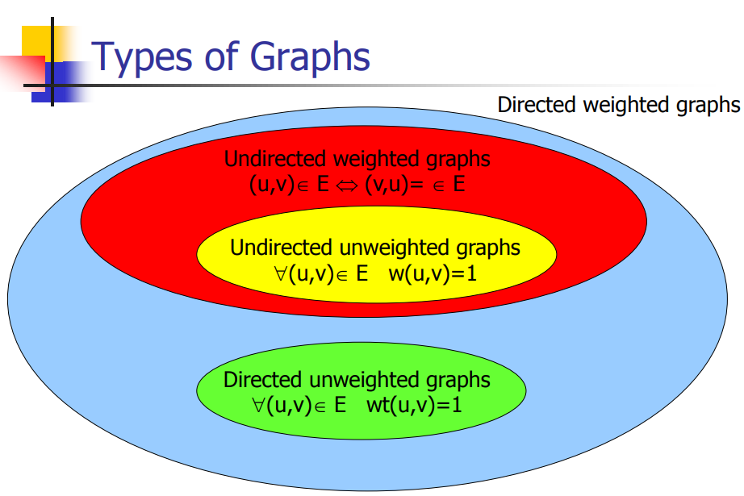

Non Rooted Trees :

Non rooted trees : undirected , connected , acyclic graph.

Forest : undirected , acyclic graph.

Properties for non-rooted graph :

Every pair of nodes is connected by single edge.

If graph is connected then removing one edge will disconnect the graph.

If graph is connected then |E|=|V|-1

If graph is acyclic then |E|=|V|-1

If graph is acyclic then adding an edge introduces a loop.

Rooted Trees :

Root ➔ NO parent.

Leaf➔ NO children.

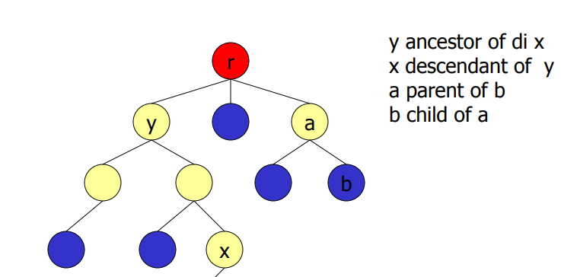

Properties of Tree : degree ➔ maximum number of children.

Depth ➔ length of the path from r to x.

Height ➔ maximum depth.

Representation of k degree tree : 1)pointer to parent.

2)key.

3)k pointers to k children

K pointers most of them can take a null pointer since the most important is the left child pointer and the right sibling pointer which is more efficient.

TREES :

Node count

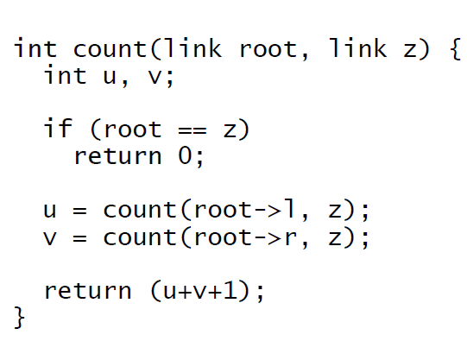

Height :

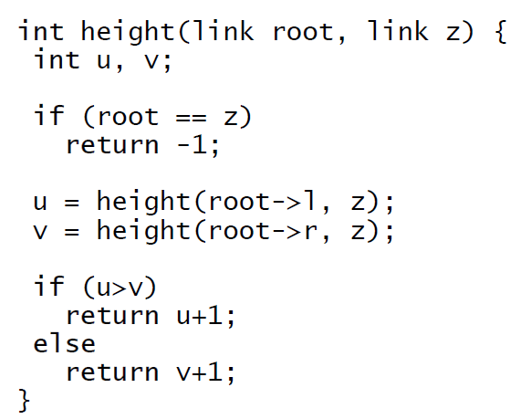

BINARY TREES :

Trees of degree 2.

Root, left subtree , right subtree.

Complete binary tree :

All leaves has the same depth.

Every node is a leaf or has two children.

Complete binary tree of height h ➔ number of leaves is 2h and number of node : 2h+1-1.

If the tree is complete then it is balanced but if it balance it is not necessary to be complete.

This tree is balanced but it isn’t complete since all path root/leaves has the same length.

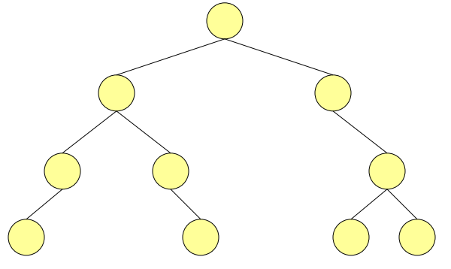

Almost balanced binary tree ➔ since the left root/leaves depth is 3 and the right root/leaves is 2.

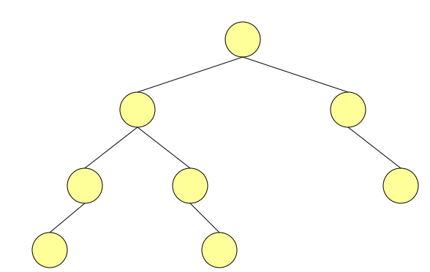

SearchBST:

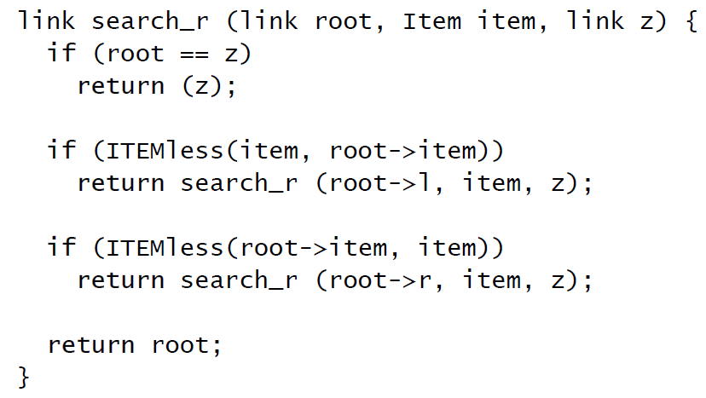

Minimum & Maximum BST:

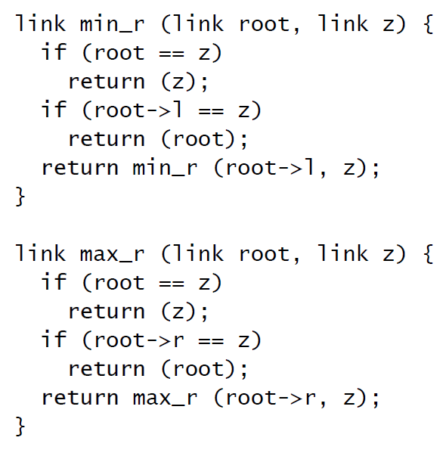

Insertnode BST:

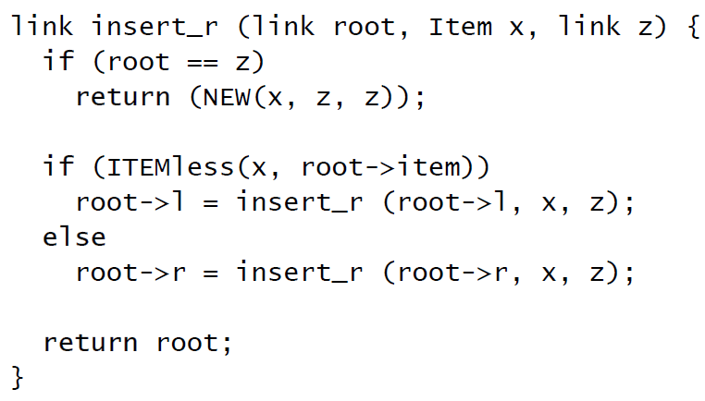

DeletenodeBst :

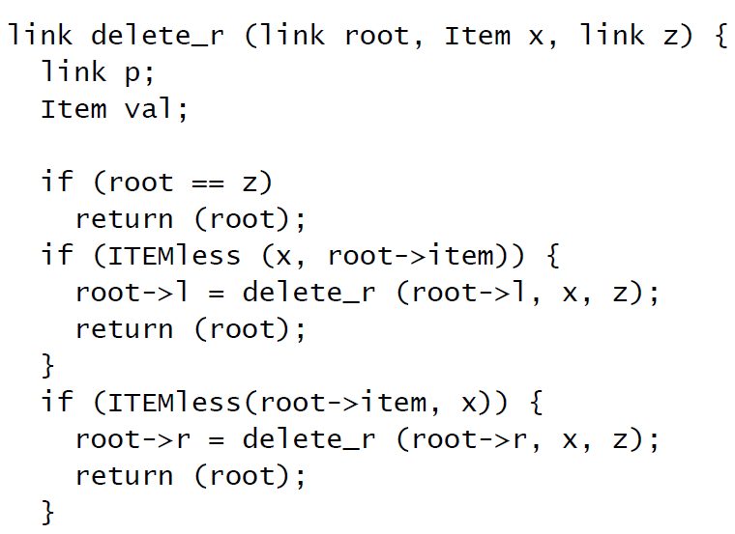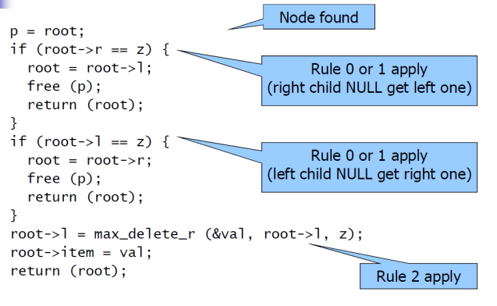

Delete Max:

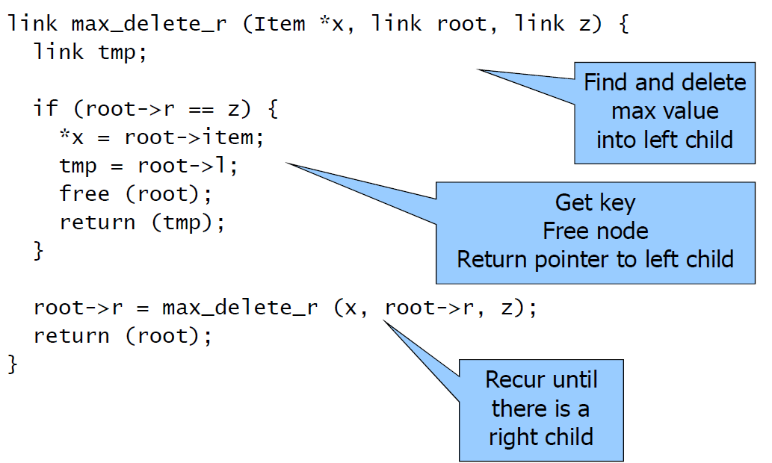

Right rotation :

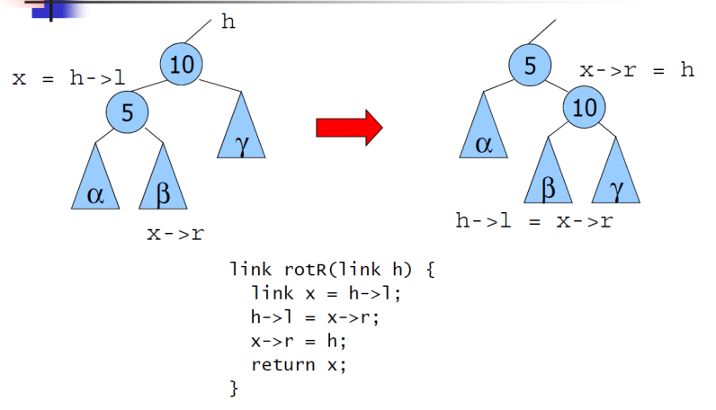

Left Rotation :

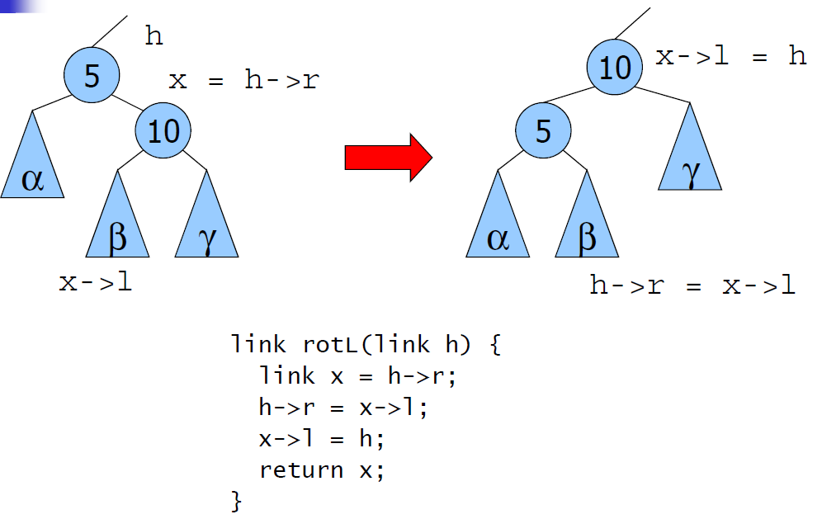

Root Insertion :

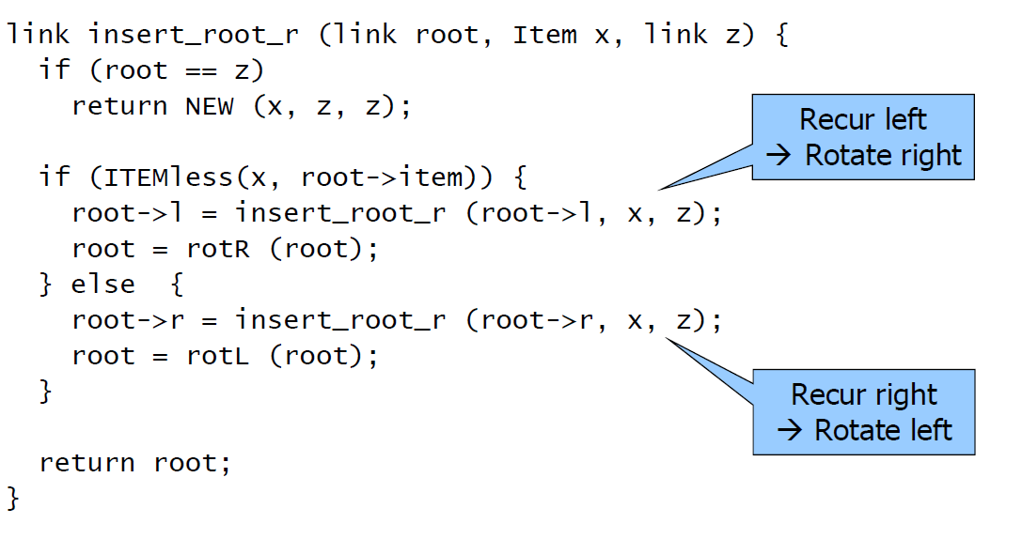

Successor of a node BST :

The structure of the tree includes parent pointer.

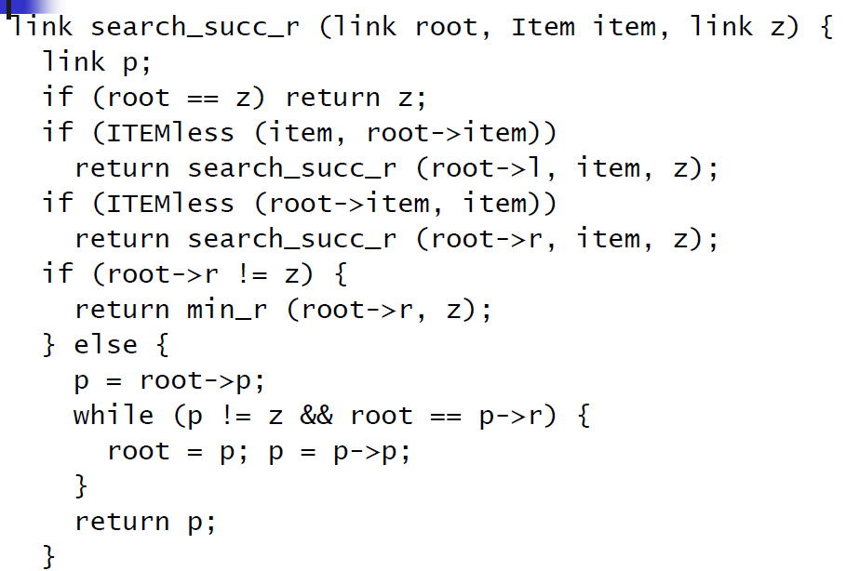

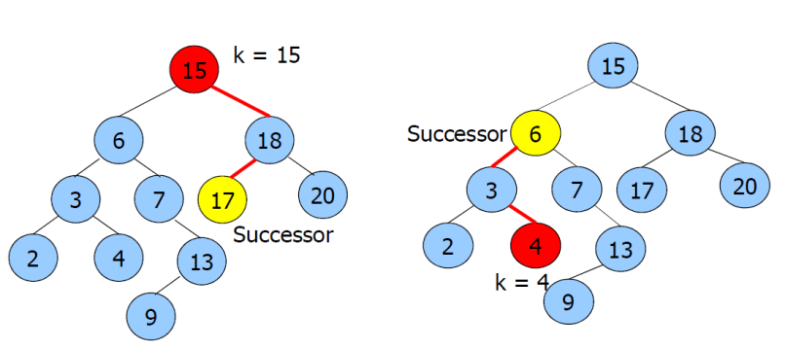

Predecessor of a node BST :

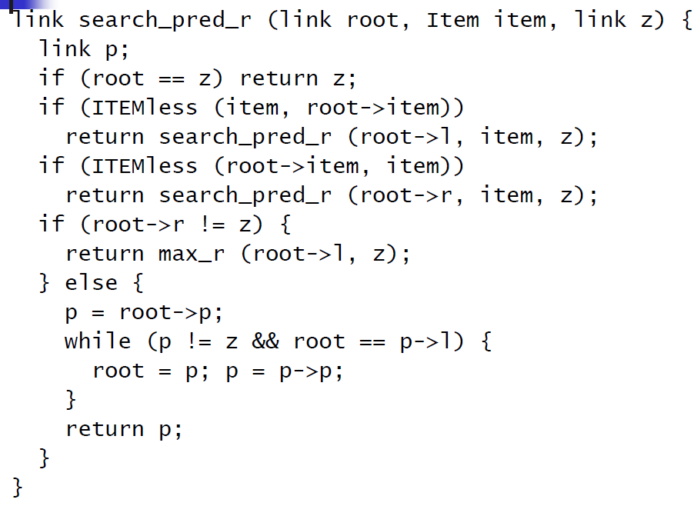

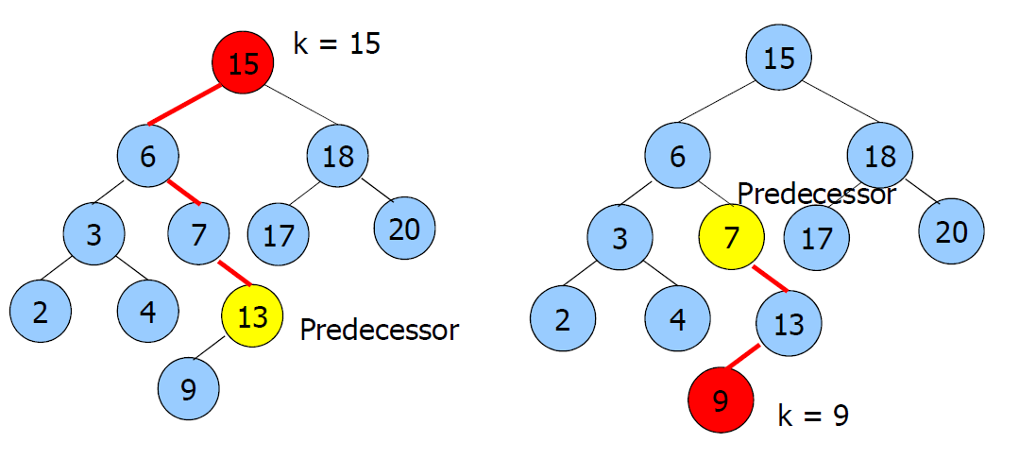

Select of a node BST : root->Left->N (N is the number of the node of the tree rooted at the current node.

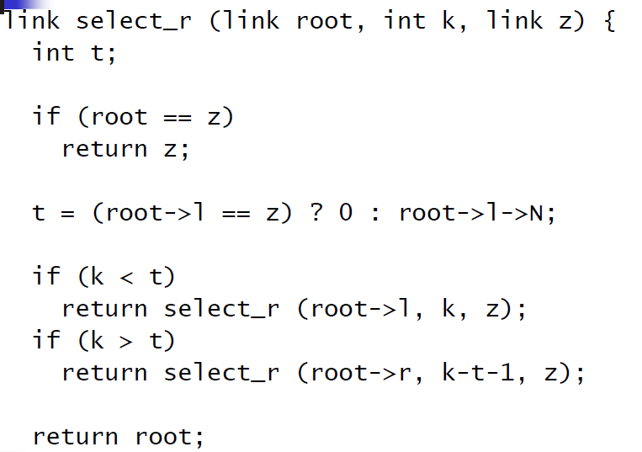

Partition of a node BST :

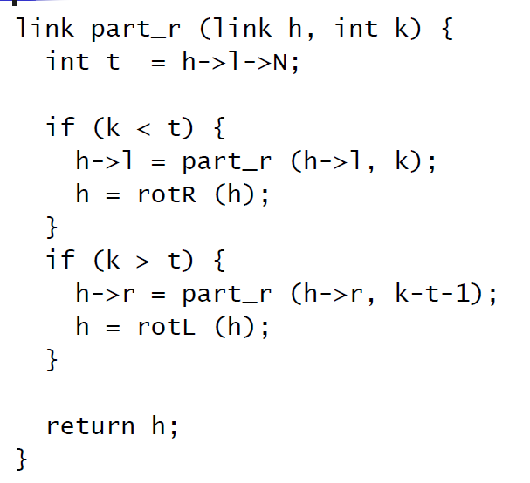

Interval BST :

Insert :

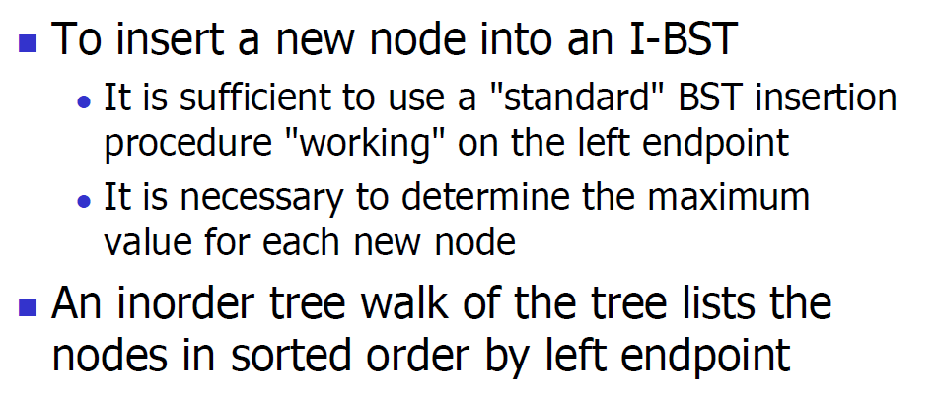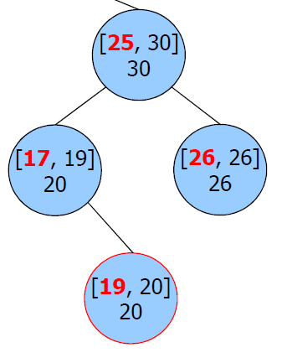

Delete :

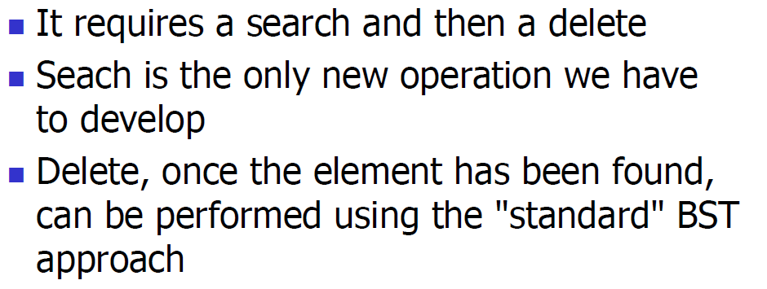

Search :

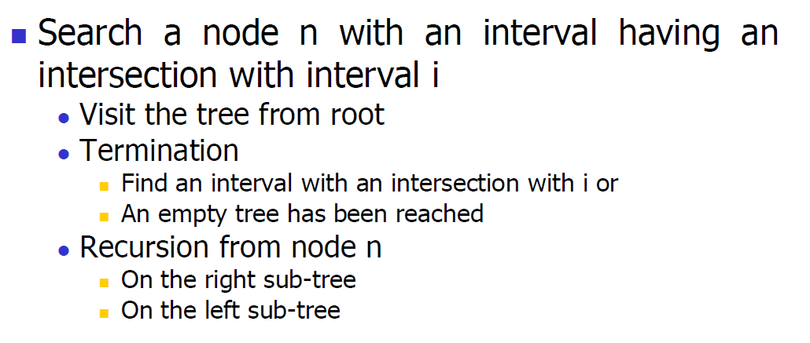

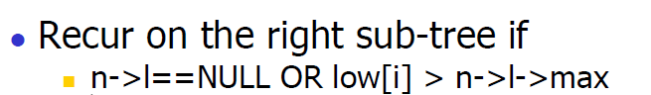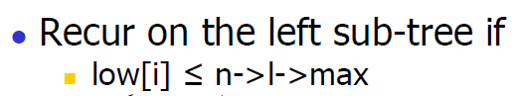

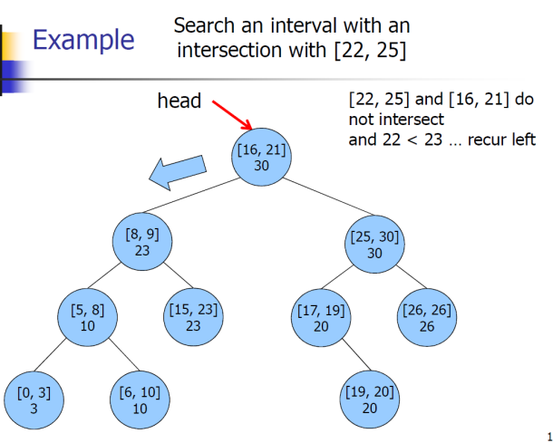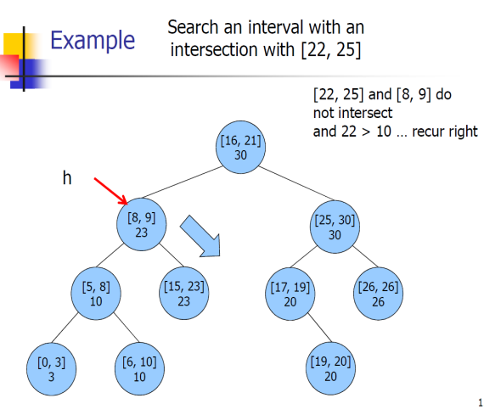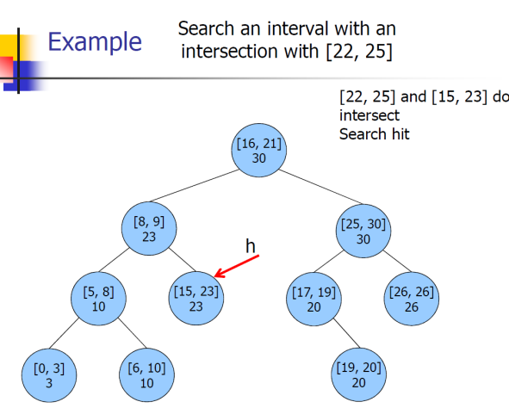

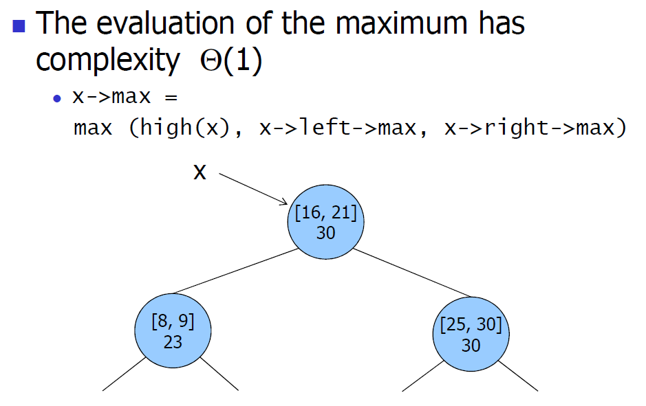

SORTING IBST COST → T(n)=O(N*logN)

INSERTION/DELETION IBST COST → T(n)=O(logN)

SEARCHING IBST COST → T(n)=O(RlogN) where R is number of intersection.

Direct Access Tables :

All search algorithms analyses are based on comparisons.

Except : DIRECT ACCESS TABLES AND HASH TABLES .
In direct access tables
1) A key k belong toU = {0, 1, …, card(U)-1}
2)Is used as the index of the array st

3)st[0, 1, …, card(U)-1]

4) maxN is the number of elements.

5) st is array storing the numbers.

Given a key k :
- Function getindex(k) returns an integer from 0 to
maxN-1, acting as an array index.
- if the key k is in the table, its position is
st[getindex(k)].
- If the key k is not in the table st[getindex(k) stores

an empty element.

- If keys are integers from 0 to maxN-1:
getindex(k) = k;
- If keys are capital letters in the English
alphabet A..Z:

getindex(k) = k – ((int) ’A’);

Insert, search, and delete complexity :T(n) = Q(1)
Init complexity :T(n) = Q(maxN)
Memory usage : S(n) = Q(|U|) = Q(maxN)

DIRECT ACCESS TABLES CAN BE USED ONLY FOR SMALL maxN.
CAN BE EXTENDED TO HASH TABLES.
USED TO CONVERT KEY TO INTEGERS WITH COST O(1).

HASH TABLES :

Memory usage equal to O(K|).

Average access time O(1).

The hash function transforms the search key into a table index.

Collision may occurs.

Used to insert , search ,delete and not to select or order.

The hash table has the size [0…M-1].

The hash function creates a correspondence between the key and table address.

Each element is stored at the address h(k) .

If the key is a floating point :

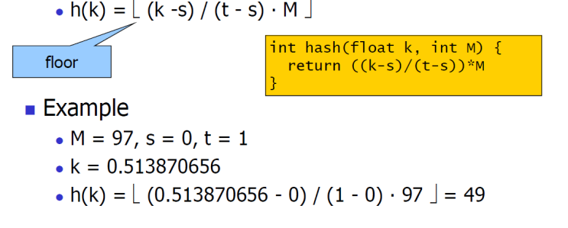

If the key is a number of w bits and M is a prime number :

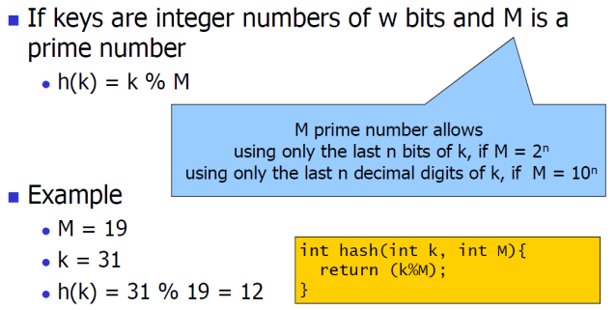

If the keys are alphanumeric Strings :

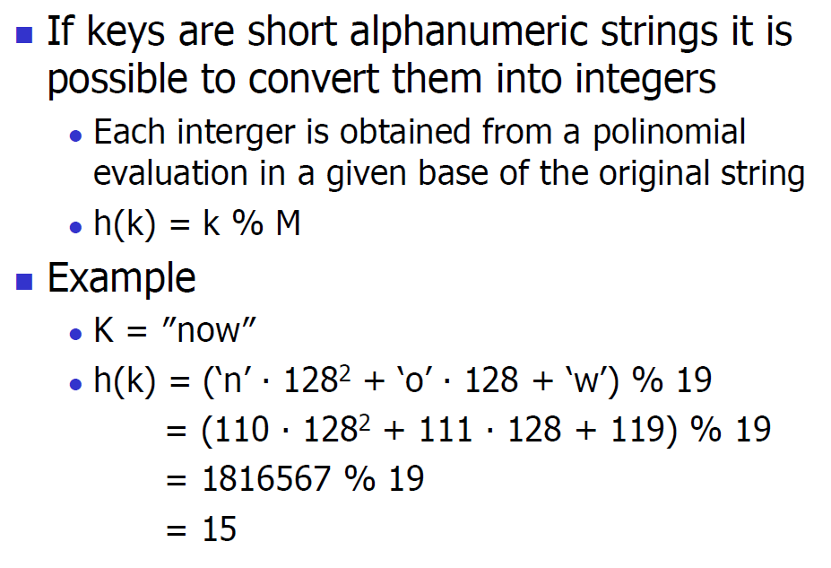

If the keys are long alphanumeric Strings :

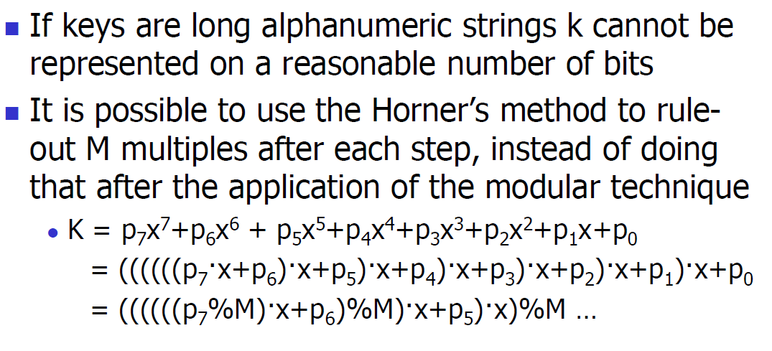

Converting keys using ASCII 128 base :

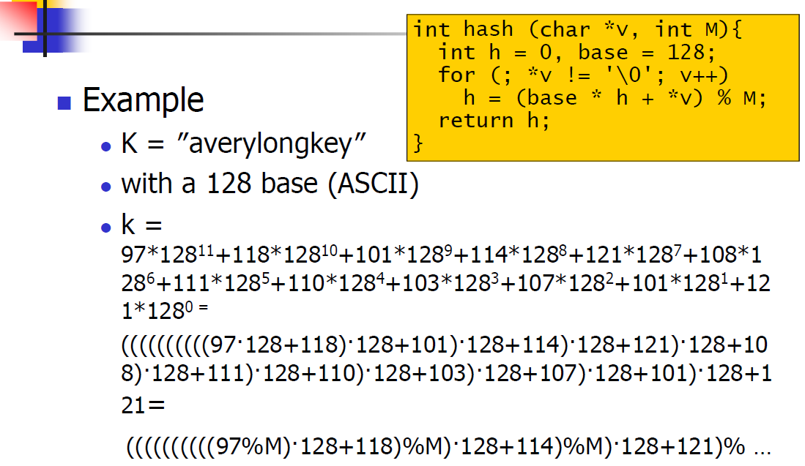

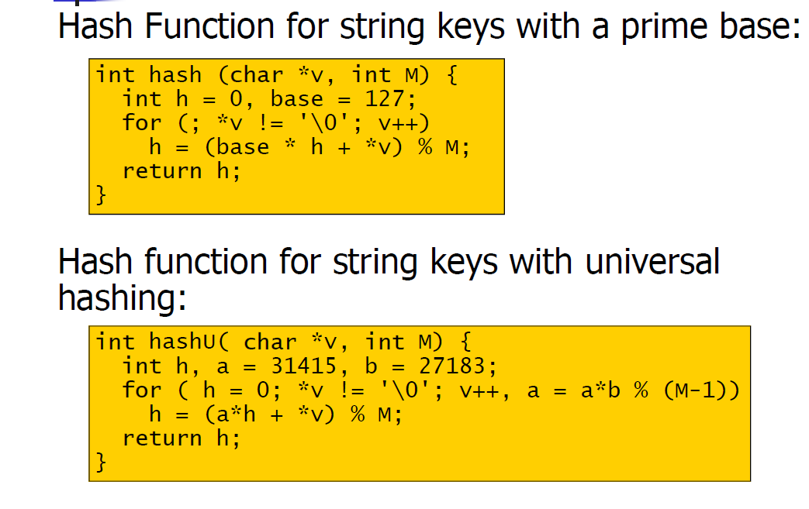

If collision happens we can deal with it with :

Linear chaining :
Operations :
Insert on the list head
List search

Delete from the list

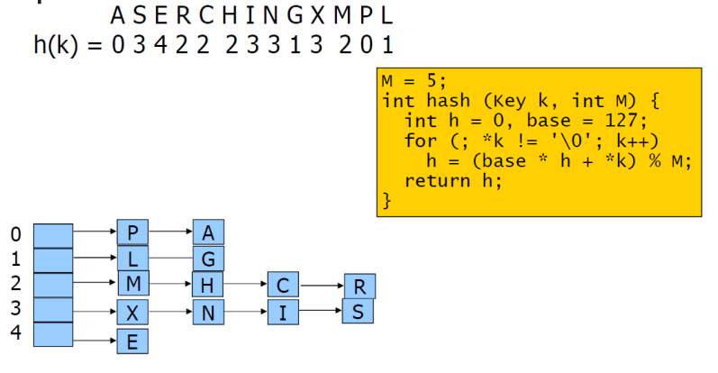
Insert :T(n) = O(1)
Search:
Worst case T(n) = Q(N)
Average case T(n) = O(1+a)
Delete :As the search.

Open addressing:

a)Linear probing .

b)Quadratic probing.

c)Double hashing.

REMARK :A problem with open addressing isclustering, that is, the presenceof clustersof contiguous full cells.

- Linear probing :
h’(k) = (h(k) + i)%M where i is the attempt counter (initially 0).

- Quadratic probing:
h‘(k) = (h(k) + c1i + c2i2)%M wherei is the attempt counter (initially 0).

If M = 2K, select c1 = c2 = ½ to generate allindexes between 0 and M-1
If M is prime and a < ½ the following values :
c1 = c2 = ½ OR c1 = c2 = 1OR c1 = 0, c2 = 1

- Double hashing:
h‘(k) = (h1 (k) + i · h2 (k))%M wherei is the attempt counter (initially 0).
EX:
h1(k) = k % M (M is prime)
h2(k) = 1 + k%97

open addressing is used when it is not necessary to delete keys or if we want to delete a key we must substitute it with a sentinel key that is considered as a full element during the search and an empty element during the insertion and that to avoid stopping the collision chains.

HASH TABLES VS TREES :

- Hash Table
Easier to implement
Unique solution with keys without an ordering relation
Faster for simple keys
- Trees (BST and variants)
Better average performances (balanced trees)
Allow operations on keys with an ordering relation

Priority Queue :
A priority queue is a data structure to store elements including a priority field such that all main operations based on this field (job scheduling).

- Pq insert :
Add a leaf to the tree.
From the current node go up to the root by comparing parent node with the new node’s key.moving the parent data from the parent to the child when the key to insert is larger,otherwise insert data into the node.
Complexity : T(n)=O(logn).

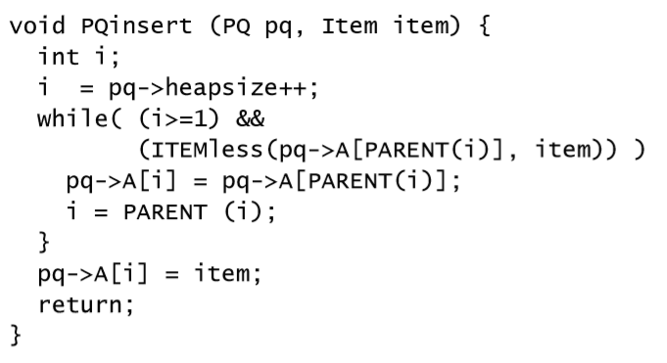
- Pq extract Max :
Modify the head by extracting the largest value,stored in the root.
Swap root with the last leaf.
Reduce by 1 the heapsize.
Restore the heap property by applying heapify.

Complexity : T(n)=O(logn)

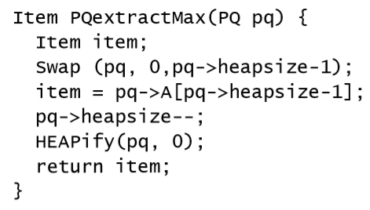

- Pq change Function :
Modify the property of an element.
Move up from given position to the root at most by comparing the parent key by the modified key.
Move down from the parent to the child to the largest key, otherwise insert the key in the current node.
Apply heapify starting from the given postion.

1) Decrease key.
2) Increase key.

Complexity : T(n)=O(logn).

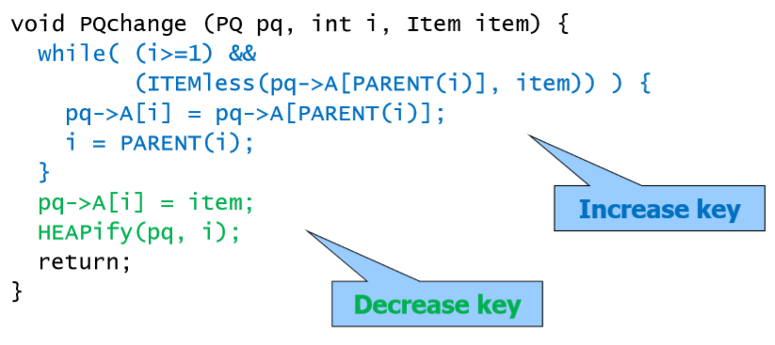
Greedy algorithm :
Do not always yield to optimal solution,but for many problems they do.
It makes a locally optimal solution in hope that this solution will lead to a global optimal solution.

- Activity selection problem.
Input set of activities with start time and end time.
Output set with the maximum number of compatible activities.
Compatibility when the activities doesn’t overlap.
Sort the activities by increasing end time.
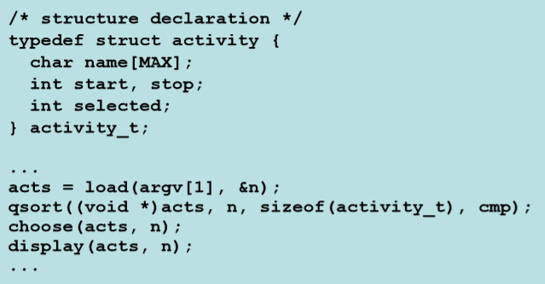
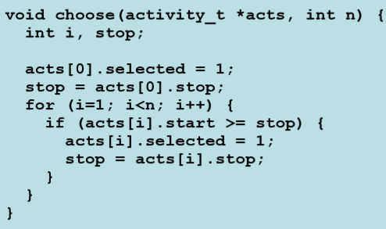
- Huffman Code :
A greedy algorithm that construct an optimal prefix code.
Codeword : strings of bits associated to a symbol,fixed length,variable length.
Encoding : from symbol to codeword.
Decoding : from codeword to symbol. 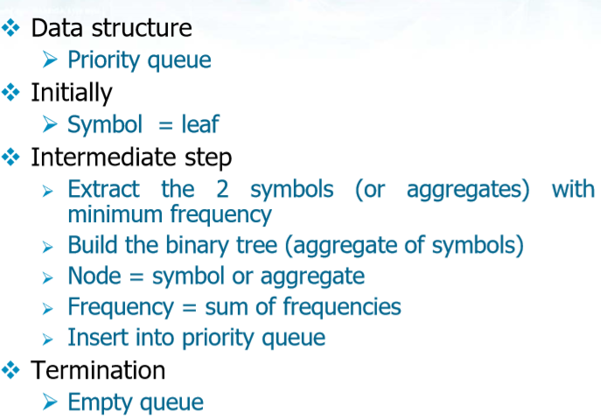
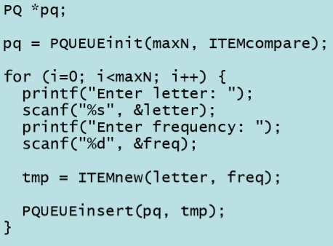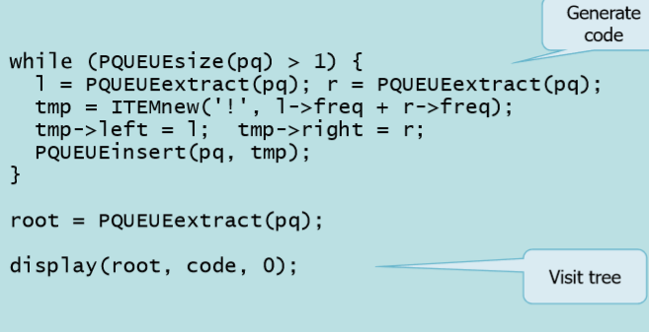

Complexity : T(n)=O(nlogn).

Graph Representation:

Both of them can be applied for directed/undirected weighted graphs.

adjacency matrix:

For undirected graph the matrix must be symmetric.

For weighted graph we use the weight between every point.

Matrix can be implemented in static or dynamic 2D.

Input file format
n-Vertex dir/undir 12 1 if=0➔undirected if notprsnt➔directed
vertex1 vertex2 weight 2 3 4 unweighted graph weight = 1.

Matrix representation Code :

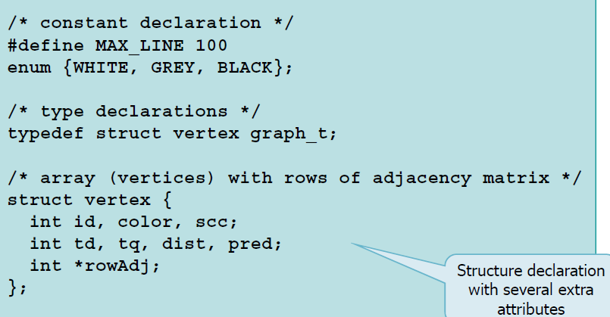

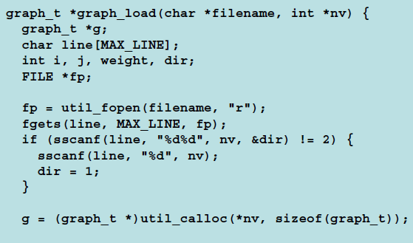

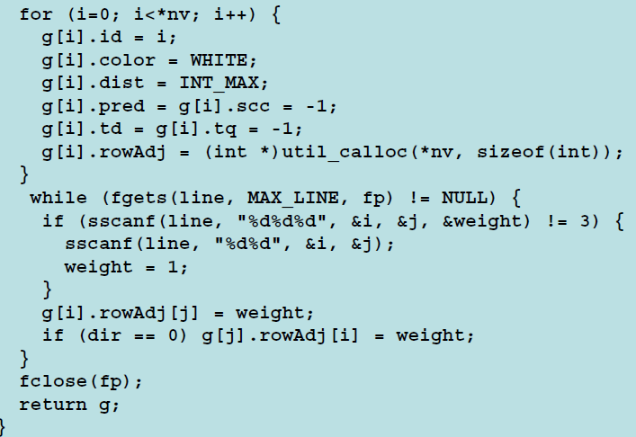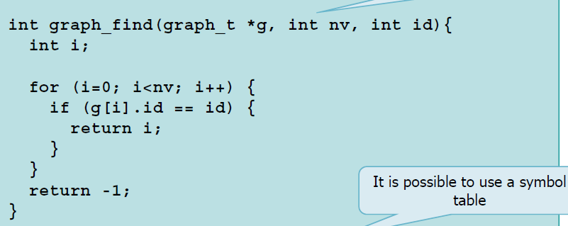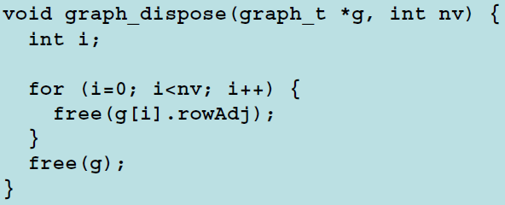

Space complexity : S(n)=O(|V|2)

Better to use it with a dense graph ➔ E approximately |V|2

2) adjacency list:

A main list representing vertices.

A secondary list of vertices or edges for each element of the main list.

Undirected graph Total amount of element in list is 2|E|.

Directed graph Total amount of elements in list is |E|.

Space complexity : S(n)=O(max(|V|,|E|))=O(|E|+|V|).

Better to use this in sparse graph which |E| is much less than |V|2

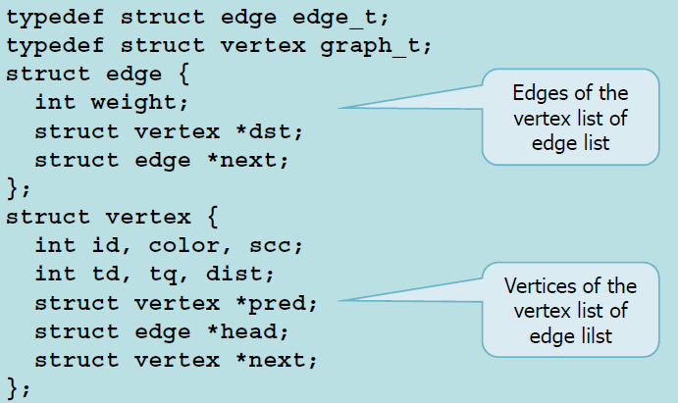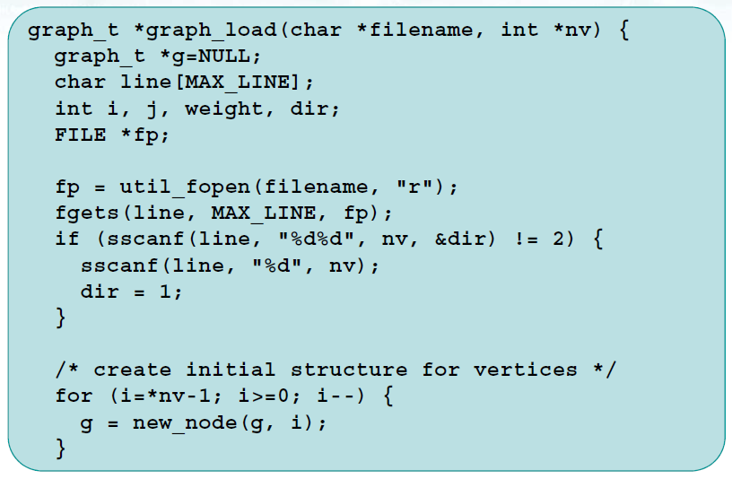

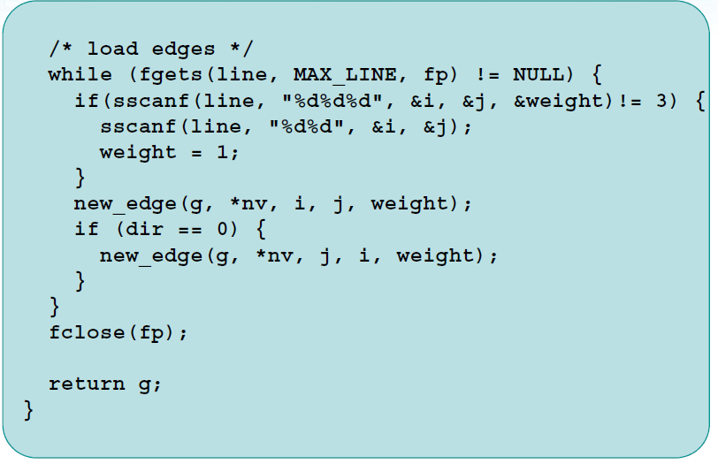

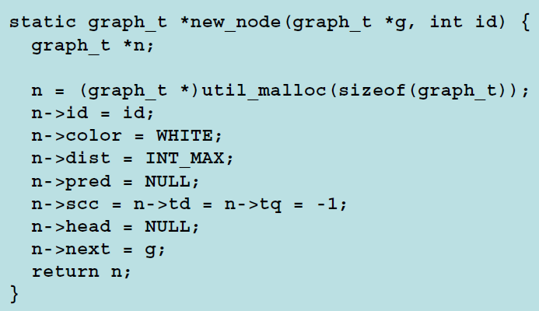

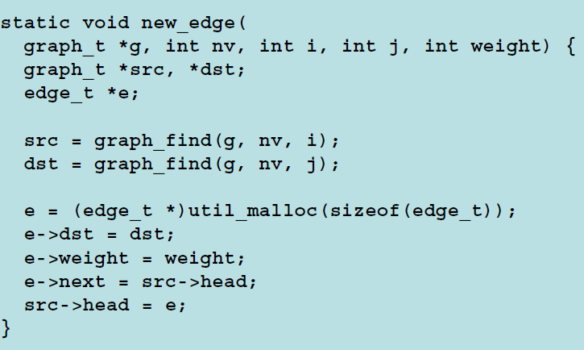

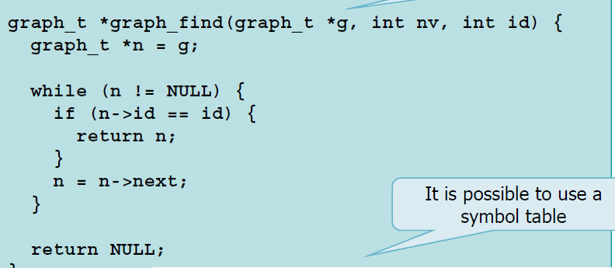

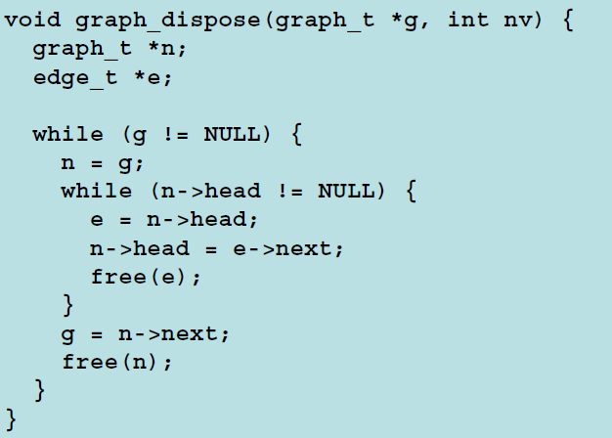

Graph Search:

Breath-First Search:

identifies all nodes reachable from source node S.

compute minimum distance from s to all the reachable node.

Generates a BFS Tree.

Expands in parallel the whole border between already discovered nodes.

Uses FIFO queue.

White→not-discovered/Gray→Discovered not completed/Black→Dis&Comp

BFS finds the shortest path between source and all nodes(Unweighted).

Used for unweighted graphs.

The cost is cost of enqueue and dequeue O(1) all vertices must be inserted in the queue then the total cost is O(V) and checking all adjacency list → O(E) then the global cost is T(n)=O(|V|+|E|)

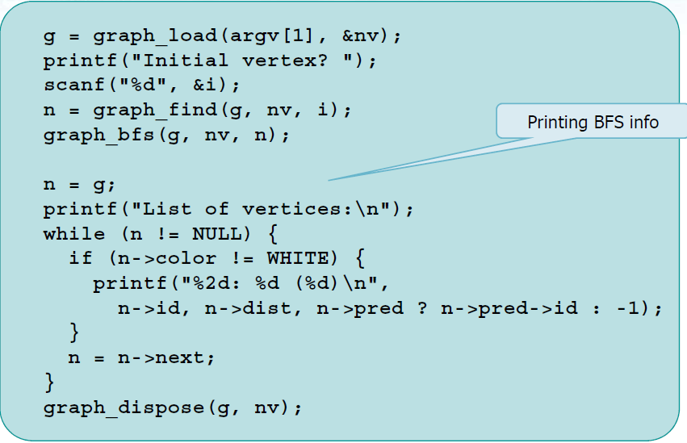

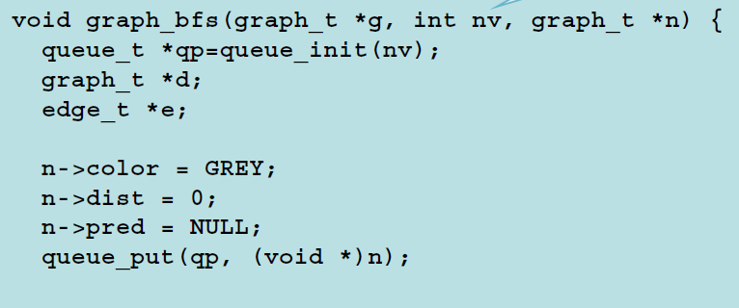

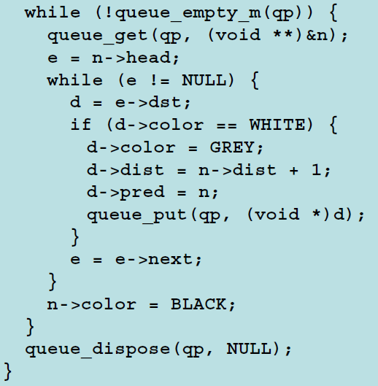

Depth-First Search:

It visits all nodes of the graph (reachable or not from source).

It labels each node v with its discovery time/end time .

It labels each edge:

Directed Graph : (TREE,BACKWARD,FORWARD,CROSS).

Undirected Graph : (TREE,BACKWARD).

It generates a forest of DFS Trees.

It expands the last discovered node that has still undiscovered adjacent nodes.

Node discovery ( pre-order visit ) root->left->right.

Completion (exit from recursion ,post-order visit).

Nodes has colors as BFS (white,gray,black).

In each node we store(discovery time pre[i],endprocess time post[i],its parent in the depth-first visit st[i]).

So in directed graph :

Tree : edges of DFS Tree.

Back : connect a node j to an ascestori in the tree,end processing i>endproccessing , i has not become black then post[i]==-1

Forward: connect a node i to a descendent j in the tree,discovery time of i<discovery time of j➔ pre[i]<pre[j].

Cross : remaining edges, discovery time of i>discovery time of j ➔pre[i]>pre[j].

So in undirected graph :

Tree : edges of DFS Tree.

Back : connect a node j to an ascestori in the tree,end processing i>endproccessing , i has not become black then post[i]==-1

Forward: connect a node j to a descendent i in the tree,discovery time of j>discovery time of i➔ pre[j]>pre[i].

Cross : remaining edges, discovery time of j<discovery time of i➔pre[j]<pre[i].

Dfs is called once on every vertex.

During each call the adjacent list of v is visited.

The overall cost T(n)=O(|V|+|E|).

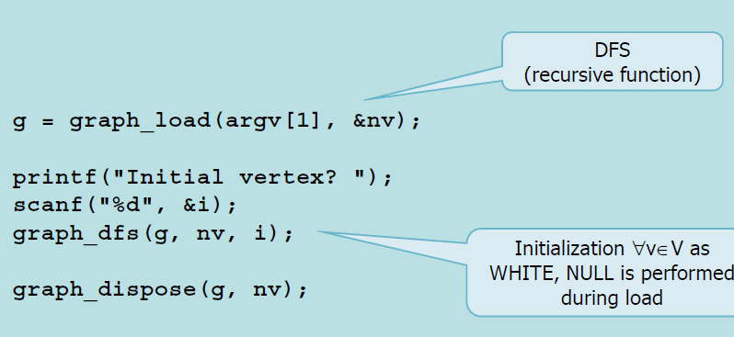

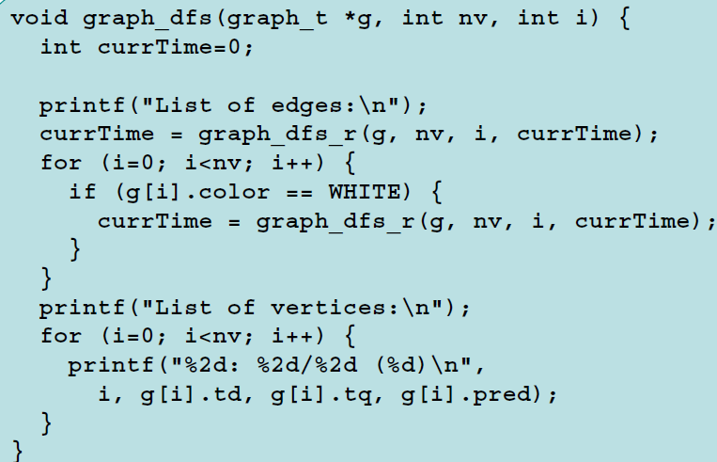

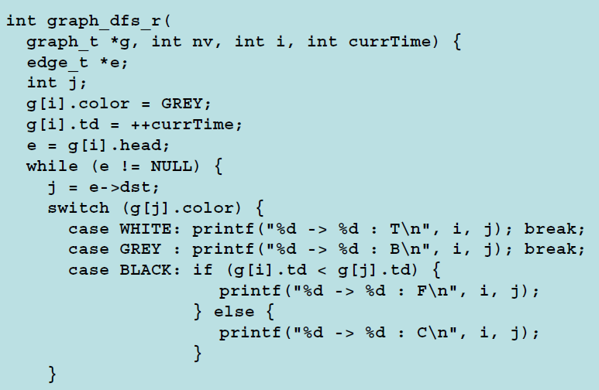

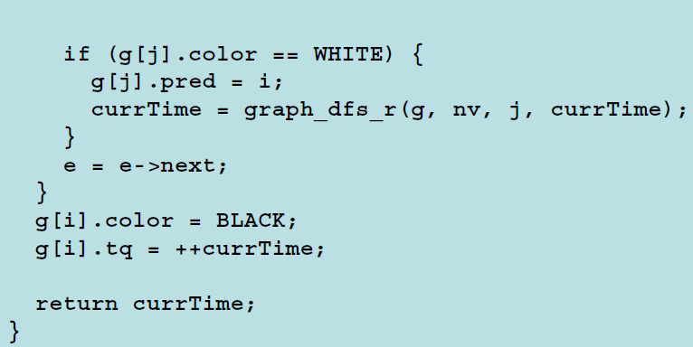

Reverse Graph :

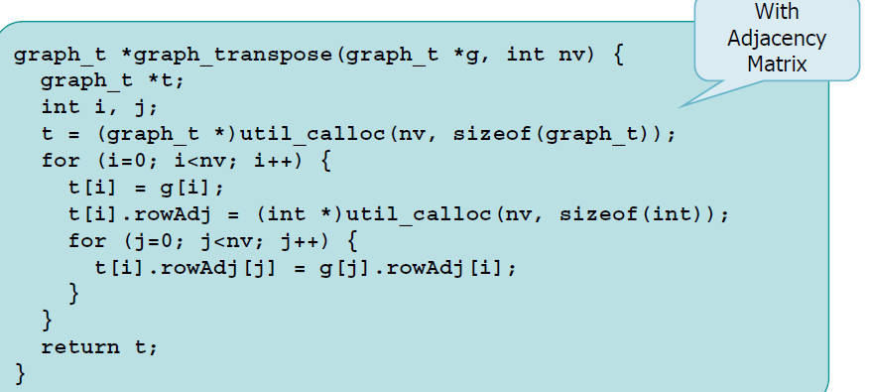

A graph is acyclic if and only if in a DFS there is no edges labelled as backward.

Bridge :

Edge whose removal disconnects the graph

Labelled Tree (T) is a bridge if and only if thereare no edges labelled Back that connect adescendant of w to an ancestor of v in the DFS tree.

Articulation Point isNode whose removal disconnects the graph:

The root of Gp is an articulation point if and only ifit has at least two children.

Leaves cannot be articulation points.

Any internal node v is an articulation point of G ifand only if v has at least one child s such thatthere is no edge labelled B from s or from one ofits descendants to a proper ancestor of v.

DAG : Directed Acyclic Graph

Algorithm
1)Perform a DFS computing end-processing times

2)Order vertices using the end-processing times

Alternative algorithm
1)Perform a DFS and when assigning end-processing

times insert the vertex into a LIFO list

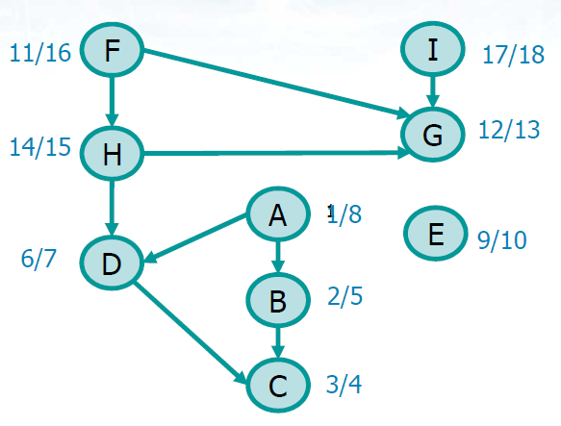

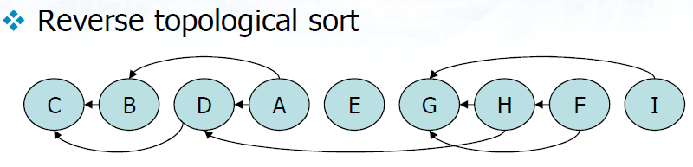

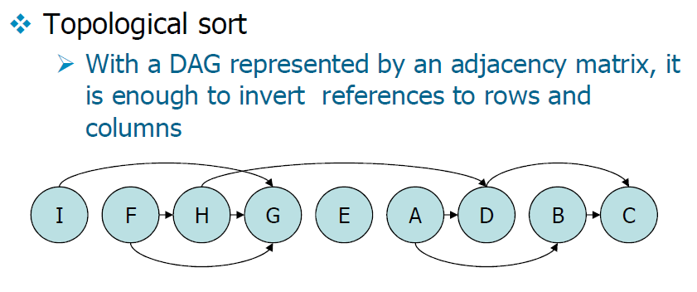

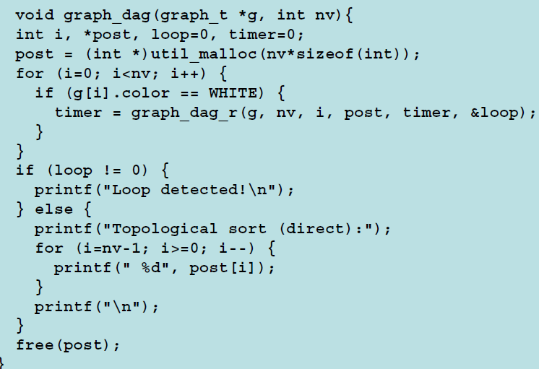

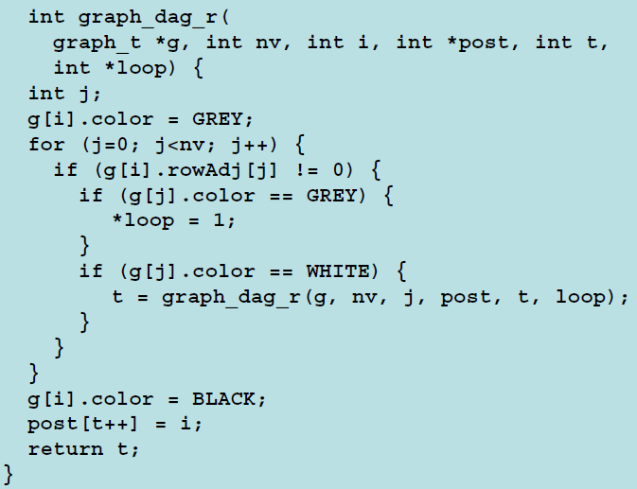

Strongly Connected Component :

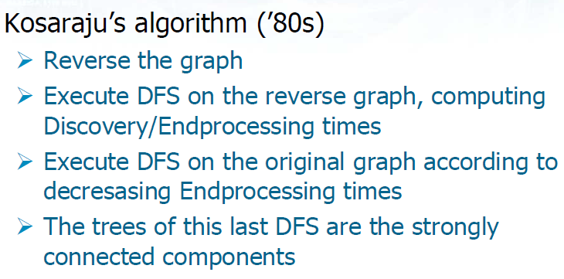

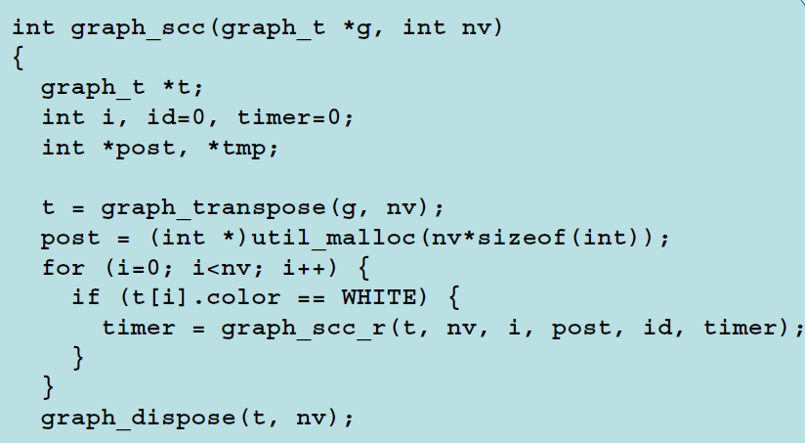

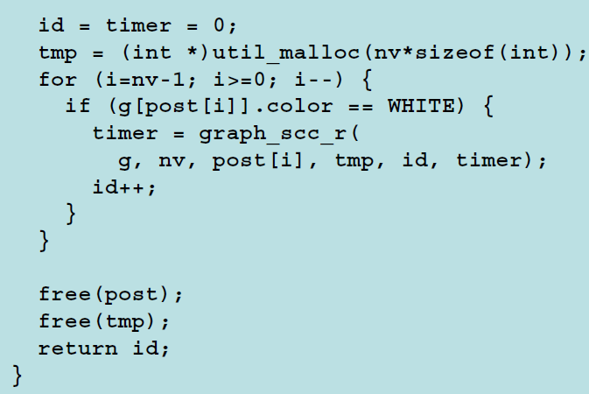

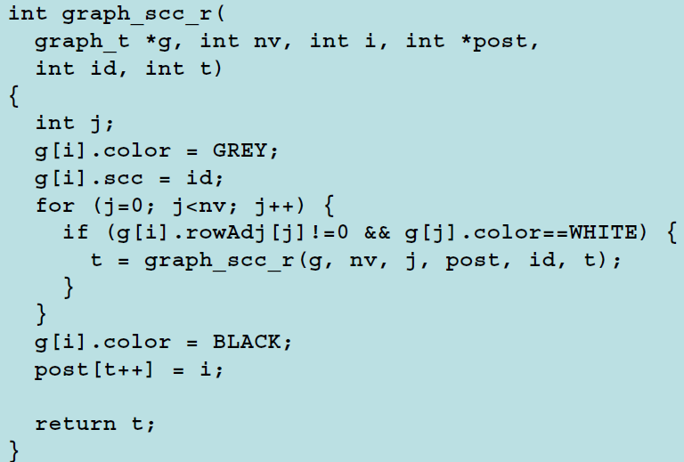

Minimum spanning tree:

A minimum weighted spanning tree G’ is Acyclic,cover all vertices.

MST is unique iff all weights are distinct.

It maybe represented as :

adjacency matrix or list.

List of edges plus weight.

List of parents plus weight.

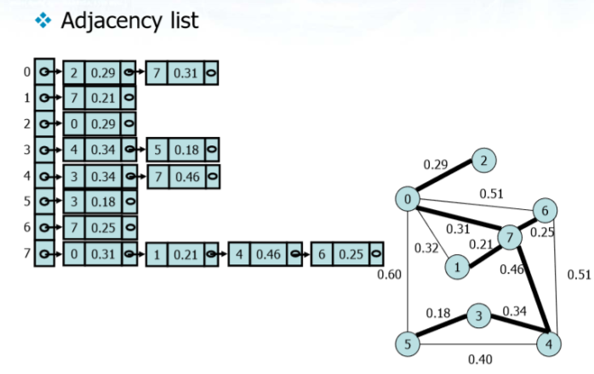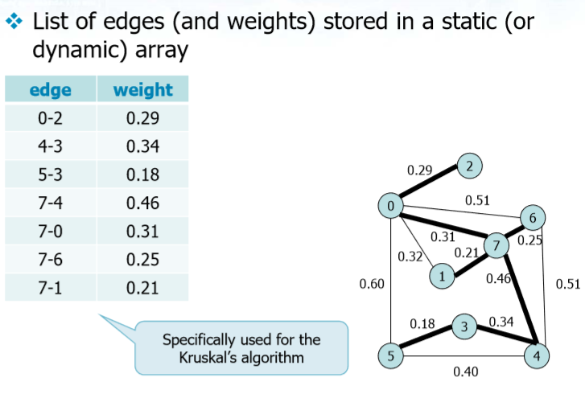

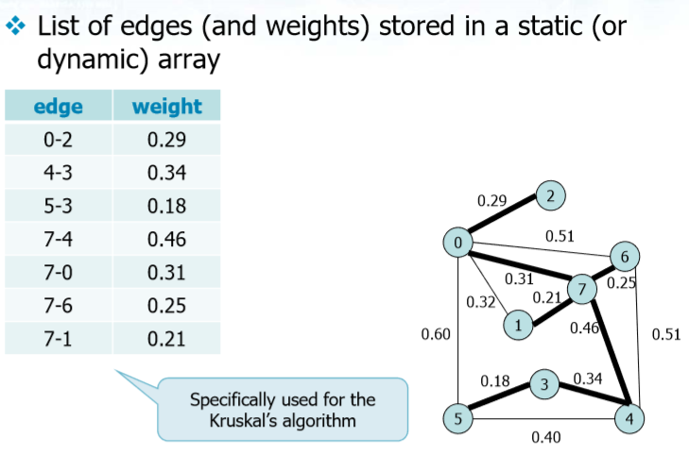

Two greedy algorithm grows a spanning tree one edge at a time:

kruskal’s algorithm.

Prim’s algorithm.

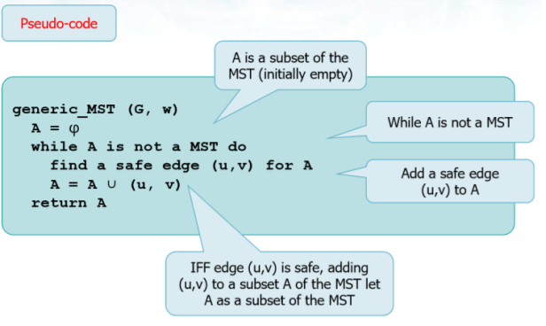

Where A is a subset of MST … initially empty.

While A is not MST then find new edge then add this edge to A.

The edge (u,v) is safe if and only if added to a subset of MST and it produces another subsets of MST.

Prim Algorithm :

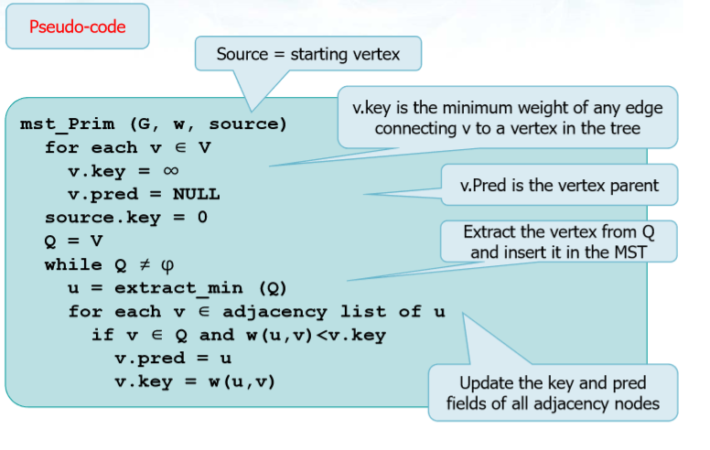

Complexity : T(n) = O(|E|.log|V|).

Kruskal’s Algorithm:

Sort edges in an increasing weight order.

Select a safe edge with minimum weight connecting two trees and generating one single tree(Union-Find).

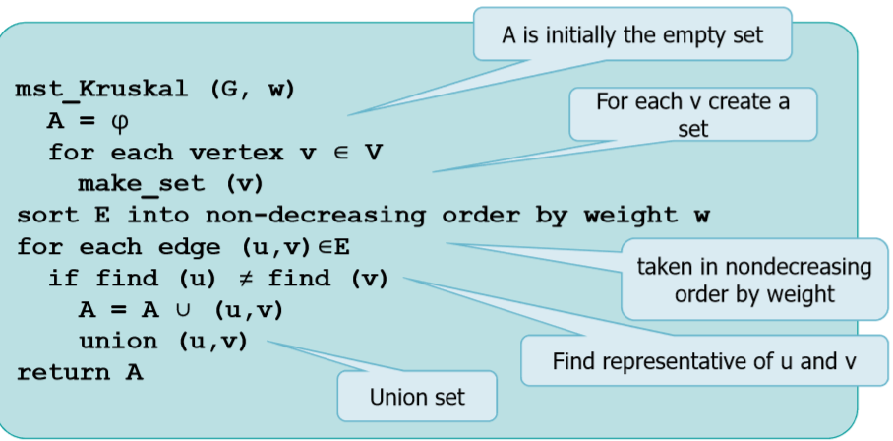

Complexity : T(n) = O(|E|.log|E|).

For dense graph prim is more efficient than kruskal.

Single Source Shortest Path :

Dijkstra’s algorithm.

Bellman-Ford algorithm.

If the graph is not weighted then a simple BFS solves the problem.

Remark :

if there is edges with negative weight:

No cycle with negative weight then :

Dijkstra’s algorithm optimum solution is not guaranted.

Bellamn-ford algorithm optimum solution guaranted.

There is cycles with negative weight then:

Dijkstra’s algorithm meaningless result.

Bellamn-ford algorithm find cycles with negative weight.

The technique we are going to analyse uses relaxation technique.

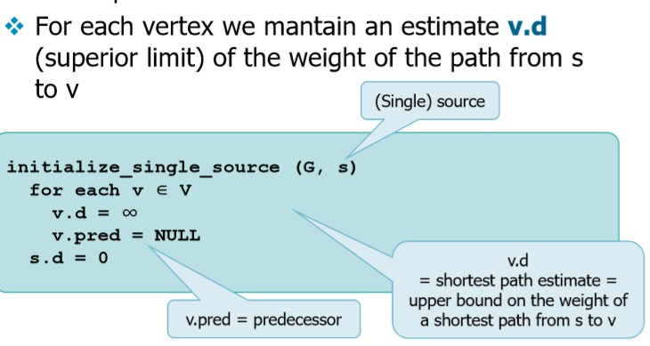

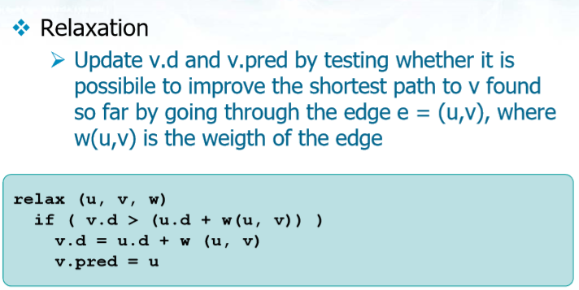

Dijkstra’s algorithm:

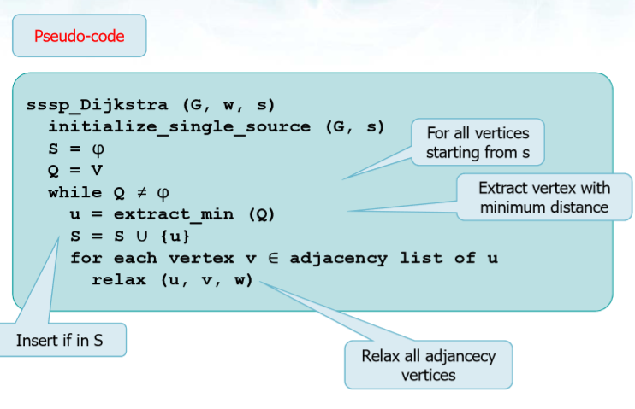

T(n)=O((|V|+|E|)∙lg|V|) can be reduced to T(n)=O(|E|∙lg|V|) if all the vertices are reachable from source s.

Bellman-Ford :

may run on graph With negative weight edges:

If there is a cycle with negative weight it detects it

It applies relaxation more than once for all edges

|V|-1 step of relaxation on all edges

At the i-th relaxation step either:

It decreases at least one estimate or It has already found an optimal solution and it can stop returning an optimum solution.

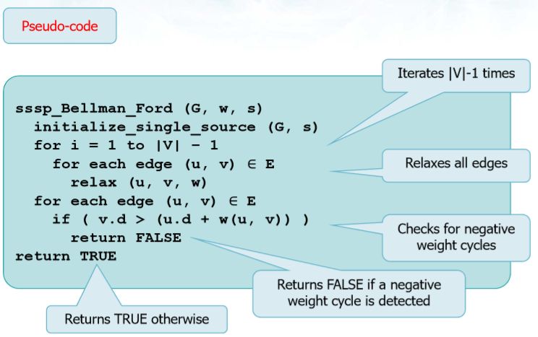

Complexity : T(n)=O(|V|∙|E|)

Shortest path on Weighted DAG:

Shortest well path are well defined even if there are negative-weighted edges and obviously negative weighted cycles cannot exists.

1)Topologically sort the DAG.

2)Relax all vertices following the sorted order gien by the topological sort.

By other words it suffices to make just one pass over the vertices in the topological sorted order so as we process the vertex we relax each edge that leaves the vertex.

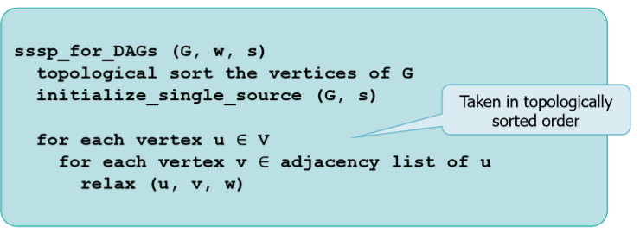

➢No negative-weight cycles can exist

Longest path on Weighted DAG:

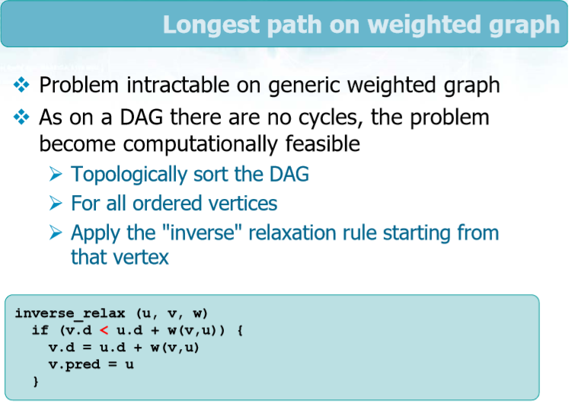

Complexity : T(n)=O(|V|+|E|)

